**Hand Book**

**Machine Learning**

**Disclaimer: The content is curated from online/offline resources and used for educational purpose only**

# Premium Vector | White abstract background in 3d paper style | Abstract backgrounds, Abstract, Geometric backgroundTable of Contents

](#_Toc181907249)

Table of Contents i

Learning Outcomes iv

Chapter 1: Introduction to Machine Learning 5

1.1 Overview of AI and ML 5

1.2 AI-ML Importance of Sustainability 16

1.3 Types of Machine Learning 18

Chapter 2: Supervised Learning 36

2.1 Introduction 36

2.2 What is Supervised Learning? 36

2.3 Labeled data 37

2.4 How Supervised Machine Learning Works? 38

2.5 Types of Supervised Learning 38

2.6 Supervised learning problems 39

2.7 Supervised Machine Learning Algorithms 40

2.24 Applications of Supervised ML Algorithms in sustainability 101

3.1 Introduction to Unsupervised Learning 104

3.2 What is Unsupervised Learning 104

3.3 Unlabeled data 105

3.4 How Unsupervised learning works? 106

3.5 Types of Unsupervised Learning and Algorithms 108

3.4 Unsupervised Learning Algorithms 108

References 136

# Premium Vector | White abstract background in 3d paper style | Abstract backgrounds, Abstract, Geometric backgroundLearning Outcomes

After completing this handbook, learner will be able to

* Define sustainability and green technology, highlighting key principles and their relevance to addressing environmental issues.
* Explain how AI and ML can support sustainability goals across various sectors, including renewable energy, waste management, water conservation, and sustainable agriculture.
* Demonstrate the ability to apply ML algorithms to analyze and interpret environmental data, such as air quality, water levels, and energy usage.
* Utilize predictive models to forecast resource needs and improve efficiency in resource consumption (e.g., energy, water) in smart cities and agriculture.
* Describe how AI and ML can be used to enhance the efficiency of renewable energy sources (solar, wind, etc.) through demand forecasting and grid management.
* Create a model that optimizes renewable energy distribution based on historical and real-time data to reduce reliance on non-renewable sources.
* Explain classification and clustering algorithms, and apply them to categorize and manage waste streams effectively.
* Develop a supervised or unsupervised ML model for sorting waste in recycling facilities, leading to better waste separation and recycling rates.
* Apply supervised learning methods to predict climate-related risks, such as temperature anomalies, flooding, and droughts.
* Utilize AI-driven tools to assess environmental impact metrics (e.g., carbon emissions) and create action plans that mitigate adverse effects on ecosystems.
* Explain and evaluate ML metrics such as accuracy, precision, recall, and F1-score, specifically in sustainability-related applications.
* Critically assess model performance in environmental monitoring applications, ensuring that models achieve both technical accuracy and ecological relevance.

# Premium Vector | White abstract background in 3d paper style | Abstract backgrounds, Abstract, Geometric backgroundChapter 1: Introduction to Machine Learning

|  |
| --- |
| **Learning Outcomes:**   * Understand the historical development and current trends in AI and ML, including their impact across various industries. * Explain the significance of AI and ML in promoting sustainability and addressing environmental challenges. * Differentiate between the main types of machine learning: supervised, unsupervised, semi-supervised, and reinforcement learning. * Outline the essential steps in a machine learning workflow, including data collection, preprocessing, model selection, training, evaluation, and deployment. * Import and implement basic ML models using Scikit-Learn, including linear regression, decision trees, and clustering algorithms. |

# Overview of AI and ML

Artificial Intelligence (AI) and Machine Learning (ML) are two interconnected fields that aim to create intelligent systems capable of performing tasks that typically require human intelligence.

**Define AI**

Artificial Intelligence (AI) is the field of computer science focused on creating systems capable of performing tasks that typically require human intelligence. It enables machines to understand, reason, learn, and respond intelligently to various types of inputs. AI systems can simulate human-like cognitive functions such as perception, decision-making, problem-solving, and even creativity.

AI-enabled apps and gadgets are able to see and recognize items. They are able to comprehend and react to human words. They are able to pick up new knowledge and skills. They are able to provide consumers and specialists with thorough advice. A self-driving car is a prime example of how they may behave autonomously, negating the requirement for human knowledge or involvement.

However, the majority of AI practitioners and researchers in 2024—as well as the majority of AI-related news stories—are centered on developments in generative AI, or "gen AI," a system that can produce original writing, photos, videos, and other types of material. Understanding machine learning (ML) and deep learning, the technologies that underpin generative AI tools, is crucial to comprehending generative AI in its entirety.

**Type of AI**

There are several ongoing advancements and discoveries in AI, the most of which may be categorized into various kinds. These divisions give us a narrative rather than a taxonomy, revealing the progress, direction, and future of artificial intelligence.

Knowing these seven forms of AI will help us anticipate what the technology will bring.

Artificial Intelligence Types,

1. Narrow AI: AI designed to complete very specific actions; unable to independently learn.
2. Artificial General Intelligence: AI designed to learn, think and perform at similar levels to humans.
3. Artificial Superintelligence: AI able to surpass the knowledge and capabilities of humans.

***Narrow AI***

Narrow AI, sometimes referred to as weak AI or artificial narrow intelligence (ANI), refers to AI technologies made to execute extremely specific orders or activities. ANI technologies are designed to support and enhance a single cognitive function; they are unable to learn new skills on their own. To accomplish these predetermined goals, they frequently use neural network techniques and machine learning.   
  
Natural language processing, for example, is a form of narrow AI since it can understand and react to voice commands but is unable to carry out other activities.   
  
AI virtual assistants, self-driving cars, and picture recognition software are a few instances of narrow AI.

***Artificial General Intelligence (AGI)***

AI that can learn, understand, and carry out a variety of tasks similarly to humans is referred to as artificial general intelligence (AGI), sometimes known as general AI or strong AI. The creation of computers that can carry out multiple activities and serve as realistic, intelligent helpers to people in daily life is the aim of artificial general intelligence research.

Although it is still in its early stages, technology like supercomputers, quantum hardware, and generative AI models like ChatGPT could lay the foundation for artificial general intelligence.

***Artificial Superintelligence***

Super AI, often known as artificial superintelligence (ASI), is the stuff of science fiction. It is predicted that if AI reaches the level of general intelligence, it would learn so quickly that its skills and knowledge will surpass even that of humanity.

The foundation of fully self-aware AI and other individualistic robots would be ASI. Its idea is also what gives rise to the "AI takeover" cliché in the media. However, it's just conjecture at this moment.

The CEO of the AI writing firm Jasper, Dave Rogenmoser, predicted that artificial superintelligence would surpass all other types of intelligence in terms of capability. "It will be incredibly superior at everything we do and possess human intelligence."

**Functionality-Based Types of Artificial Intelligence**

Functionality refers to how an AI uses its capacity for learning to digest information, react to external stimuli, and engage with its surroundings. As a result, there are four categories of capabilities for AI.

Functionality based AI types,

1. Reactive Machine AI: AI capable of responding to external stimuli in real time; unable to build memory or store information for future.
2. Limited Memory AI: AI that can store knowledge and use it to learn and train for future tasks.
3. Theory of Mind AI: AI that can sense and respond to human emotions, plus perform the tasks of limited memory machines.
4. Self-Aware AI: AI that can recognize others’ emotions, plus has sense of self and human-level intelligence; the final stage of AI.

***Reactive Machine AI***

Simply put, reactive machines are simply that—reactive. They are not able to store memories, learn from past events, or enhance their functionality via experience, but they can react to demands and duties instantly. Furthermore, only a restricted set of input combinations can cause reactive machines to react. The most basic form of artificial intelligence is reactive machines.

Reactive machines can effectively carry out simple autonomous tasks like removing spam from your email inbox or making product recommendations based on your past purchases. However, reactive AI is unable to carry out more complicated tasks or expand on prior knowledge.

Example, Netflix Recommendation Engine: AI-powered recommendation engines are frequently used by media platforms such as Netflix. These engines analyze user viewing history data to identify and recommend content that users are most likely to watch next.

***Limited Memory AI***

Limited memory AI has the ability to store historical data and utilize it to forecast future events. This indicates that it actively creates its own little, temporary knowledge base and uses it to carry out tasks.

Deep learning, which mimics how neurons work in the human brain, is the foundation of limited memory AI. This enables a machine to take in information from events and "learn" from them, thereby increasing the precision of its actions.

The vast majority of AI applications nowadays are based on the limited memory paradigm. It can be used in many different contexts, ranging from more complex use cases like self-driving cars to smaller-scale applications like chatbots.

Example, Chatbots and virtual assistants are limited memory artificial intelligence (AI) systems that simulate human speech through deep learning. These systems learn from this data and retain user-specific information when users engage with them more frequently, enabling them to respond in a way that is pertinent and tailored to each individual.

***Theory of Mind AI***

The idea of artificial intelligence (AI) that is able to sense and understand other people's emotions is known as theory of mind. The phrase, which comes from psychology, refers to people's capacity to read other people's emotions and make predictions about their behavior based on that knowledge. Though it hasn't been fully developed yet, theory of mind represents the next significant advancement in AI.

Example, To demonstrate how a good theory of mind application will transform the technology, Rafael Tena, senior AI researcher at insurance business Acrisure, gave the following example: Because it won't make the same mistakes as a human driver, a self-driving car might outperform one in most situations. However, as a driver, you will naturally know to slow down when you pass your neighbor's driveway if you know that their child frequently plays near the road after school. This is something that an AI car with rudimentary memory wouldn't be able to achieve.

***Self-Aware AI***

Artificial intelligence with self-awareness is referred to as self-aware AI. One of the ultimate objectives in AI development is self-aware AI, often known as the AI point of singularity, which is the level beyond theory of mind. Since self-aware AI would not only be able to experience other people's emotions but will also have a sense of self, it is believed that once this technology is developed, AI machines will be uncontrollable.

Example, Sophia, a robot created by Hanson Robotics, is arguably the most well-known of these. Sophia's sophisticated use of existing AI technology offers a preview of the possibility for self-aware AI in the future, even though it is not yet self-aware. There is disagreement about whether it is morally acceptable to create sentient AI at all, and the future holds both promise and peril.

**Understanding AI Concepts**

Understanding AI concepts is essential for leveraging AI effectively and responsibly. This includes not only the technical foundations but also the ethical, legal, and societal impacts of AI systems. Responsible AI practices ensure that AI technology benefits society and minimizes unintended harm.

**AI Concepts**

***Machine Learning (ML) and Deep Learning (DL)***

Machine Learning (ML) and Deep Learning (DL) are key branches of Artificial Intelligence (AI) focused on enabling systems to learn from data.

Machine Learning is a broader field that involves using algorithms to recognize patterns, make predictions, or categorize data based on examples provided. ML includes several learning types:

* Supervised Learning, where models are trained on labeled data, meaning each example is tagged with the correct output (e.g., spam or non-spam email classification).
* Unsupervised Learning, where models find patterns in unlabeled data (e.g., customer segmentation).
* Reinforcement Learning, where agents learn by interacting with their environment and receiving feedback based on their actions, commonly applied in robotics and game AI.

Deep Learning is a specialized subset of ML that leverages neural networks with multiple layers (hence "deep") to model complex patterns in large datasets. Neural networks are inspired by the human brain and are particularly effective at handling unstructured data like images, text, and audio. Deep learning architectures include:

* Convolutional Neural Networks (CNNs), mainly used for image processing and visual recognition tasks by applying filters to detect features like edges or colors.
* Recurrent Neural Networks (RNNs), suitable for sequence data (e.g., language or time-series data), where past information is crucial for current predictions.

Deep Learning has fueled advances in areas like natural language processing (NLP), self-driving cars, and medical image analysis due to its ability to extract hierarchical features automatically, given large amounts of data. While both ML and DL are transformative, DL is more computationally intensive and requires substantial data for training but often achieves state-of-the-art performance in tasks that involve complex, high-dimensional data. Together, ML and DL enable intelligent, adaptive systems that can continually improve through data, shaping many AI applications we encounter today.

***Natural Language Processing (NLP)***

Natural Language Processing (NLP) is a field of artificial intelligence that focuses on enabling computers to understand, interpret, and respond to human language in a valuable way. NLP combines computational linguistics—drawing from computer science and linguistics—with machine learning and deep learning techniques to bridge the communication gap between humans and machines.

Key tasks in NLP include text classification, sentiment analysis, machine translation, speech recognition, and chatbots. These tasks allow machines to process natural language by transforming it into structured data that can be analyzed. For instance, sentiment analysis helps determine the sentiment behind text, such as positive, negative, or neutral, which is useful in customer feedback analysis. Machine translation—translating text from one language to another—uses deep learning models to improve translation accuracy.

NLP techniques include tokenization (splitting text into words or sentences), stemming and lemmatization (reducing words to their root forms), and word embeddings (representing words as vectors in continuous space). Recent advances like transformers, such as BERT and GPT, have significantly improved NLP by using self-attention mechanisms to capture context better, making language understanding more accurate and nuanced.

Challenges in NLP include ambiguity, context understanding, and language diversity. Ambiguity in language—where words have multiple meanings based on context—requires sophisticated models to interpret correctly. Additionally, NLP systems must handle different languages, dialects, and colloquialisms.

NLP is widely used in virtual assistants, social media monitoring, and automated customer support, among other applications. It has transformed how businesses interact with customers and how information is processed, making it one of the most impactful areas in AI. As NLP technology continues to evolve, it promises even greater advancements in language comprehension and interaction between humans and machines.

***Computer Vision***

Computer Vision (CV) is a field of artificial intelligence focused on enabling machines to interpret and understand visual data, much like human vision. It involves the automated extraction, analysis, and understanding of useful information from images, videos, and other visual inputs to make decisions or perform actions based on that data.

Computer vision works by processing raw visual data (pixels in images or frames in videos) and using algorithms to recognize patterns, detect objects, or understand scenes. Advances in machine learning and deep learning, particularly the development of Convolutional Neural Networks (CNNs), have significantly enhanced computer vision’s capabilities, enabling it to handle complex tasks such as facial recognition, object detection, and image classification with high accuracy.

Computer vision has broad applications, from healthcare (medical imaging analysis) to retail (inventory management and customer behavior analysis) and security (surveillance). With ongoing advancements, computer vision systems are becoming more robust, efficient, and adaptable, driving innovation in areas where understanding visual data is essential for intelligent decision-making.

***Reinforcement Learning (RL)***

Reinforcement Learning (RL) is an area of machine learning where an agent learns to make decisions by interacting with an environment to achieve a specific goal. Unlike supervised learning, where labeled data guides the model, RL relies on feedback in the form of rewards and penalties. The agent’s objective is to maximize cumulative rewards over time, often balancing short-term gains with long-term benefits.

In RL, an agent observes the current state of the environment, takes an action based on that observation, and receives feedback. This feedback, or reward, indicates the quality of the action taken, influencing future decisions. Actions chosen in each state form a policy—the strategy the agent follows to maximize rewards. The value of states or actions, predicted by value functions, helps the agent assess long-term rewards associated with particular decisions.

Key RL techniques include Q-learning and policy gradients. In Q-learning, the agent learns a Q-value for each action in a given state, which estimates the expected reward for that action. Policy gradients, on the other hand, involve optimizing the policy directly, focusing on actions likely to yield the highest rewards over time.

RL has applications across diverse fields. In gaming, RL enables AI agents to learn complex strategies in games like Go or StarCraft. In robotics, RL allows robots to learn tasks like walking or grasping objects by trial and error. RL also drives advancements in autonomous systems, helping them navigate dynamic environments.

One challenge with RL is balancing exploration (trying new actions to discover better rewards) and exploitation (choosing known actions to maximize rewards). Despite its complexity, RL’s potential for developing adaptive, autonomous systems makes it an exciting area of AI research and application.

***Generative Models***

Generative models are a type of machine learning model designed to generate new data that resembles the data on which they were trained. Unlike traditional discriminative models, which predict labels or classify data, generative models learn the underlying patterns and distribution of a dataset, allowing them to create new samples similar to the original data.

Two popular types of generative models are Generative Adversarial Networks (GANs) and Variational Autoencoders (VAEs).

Generative Adversarial Networks (GANs): GANs consist of two neural networks: a generator and a discriminator. The generator creates synthetic data, while the discriminator evaluates its authenticity, distinguishing between real and generated data. These networks compete in a game-like setting, where the generator improves its ability to produce realistic samples while the discriminator becomes better at identifying fakes. GANs are widely used for applications like image generation, style transfer, and even creating realistic human faces.

Variational Autoencoders (VAEs): VAEs use a probabilistic approach to generate data. They compress input data into a lower-dimensional "latent space" and then reconstruct it. By sampling from this latent space, VAEs can generate new data points similar to the original dataset. VAEs are commonly applied in tasks like image synthesis, anomaly detection, and drug discovery.

Generative models have vast applications across various fields. In healthcare, they can generate synthetic data for medical research, preserving privacy. In entertainment, they’re used to create new music, artwork, and game content. In science, they aid in simulations and drug molecule generation.

However, generative models also raise ethical concerns, particularly with deepfakes and synthetic media, which can be misused for deceptive purposes. Responsible use and safeguards are essential as these models become more powerful and widely used.

***Explainable AI (XAI)***

Explainable AI (XAI) refers to methods and techniques that make the decision-making processes of artificial intelligence systems transparent and understandable to humans. As AI technologies, especially those based on machine learning and deep learning, have become increasingly complex, the need for interpretability has grown. XAI addresses the “black box” nature of many AI models, where it can be difficult to ascertain how decisions are made, potentially undermining trust in AI applications.

The primary goal of XAI is to provide insights into the inner workings of AI models, enabling users to understand how inputs are transformed into outputs. This is particularly crucial in high-stakes areas such as healthcare, finance, and criminal justice, where AI decisions can significantly impact individuals’ lives. For instance, in healthcare, a model predicting disease risks needs to explain its reasoning to physicians so they can trust its recommendations.

XAI encompasses various techniques and approaches. For example, post-hoc interpretability methods analyze and explain model behavior after training, using tools like SHAP (Shapley Additive Explanations) and LIME (Local Interpretable Model-Agnostic Explanations). These tools highlight which features influenced a specific decision, allowing users to gain insights into model predictions. Another approach is transparent models, such as decision trees or linear regression, which are inherently easier to interpret but may sacrifice some predictive power.

Implementing XAI fosters greater accountability, allowing developers and stakeholders to identify potential biases and errors in AI systems. As organizations increasingly adopt AI, the importance of explainability cannot be overstated. By enhancing transparency, XAI not only builds user trust but also aligns AI applications with ethical standards, ultimately contributing to more responsible and beneficial AI deployment.

**Relationship between AI and ML**

The relationship between Artificial Intelligence (AI) and Machine Learning (ML) is both foundational and interdependent. AI is the broader field focused on creating systems that can perform tasks typically requiring human intelligence, such as reasoning, problem-solving, understanding natural language, and perception. It encompasses a wide range of technologies, including robotics, computer vision, natural language processing, and more.

Machine Learning, on the other hand, is a subset of AI that specifically emphasizes the development of algorithms and statistical models that enable computers to learn from and make predictions based on data. Instead of being explicitly programmed for every task, ML algorithms identify patterns and improve their performance as they are exposed to more data. This self-improving capability makes ML particularly powerful for tasks where traditional programming would be impractical due to the complexity or variability of the data.

Within ML, there are several techniques, such as supervised learning, unsupervised learning, and reinforcement learning, each serving different purposes and applications. For instance, supervised learning is used for classification and regression tasks, while unsupervised learning helps identify hidden structures in data.

The synergy between AI and ML is evident in various applications. For example, AI systems that utilize ML can enhance customer service through chatbots that understand and respond to user inquiries. Additionally, AI can leverage ML algorithms for tasks such as predictive analytics, enabling businesses to anticipate market trends and customer behavior**.**

**History of AI**

The history of Artificial Intelligence (AI) spans several decades, marked by significant milestones and shifts in research focus.

The concept of AI began in ancient history, with myths and stories of artificial beings possessing intelligence. However, the formal study of AI began in the mid-20th century. In 1956, the Dartmouth Conference, organized by John McCarthy, Marvin Minsky, Nathaniel Rochester, and Claude Shannon, is often considered the birth of AI as a field. Researchers aimed to explore ways to make machines simulate human intelligence.

During the 1960s and 1970s, early AI programs, like ELIZA, a natural language processing program created by Joseph Weizenbaum, showcased the potential for machines to engage in conversation. However, the optimism of this period led to what is known as the "AI winter" in the late 1970s and 1980s, where funding and interest in AI research declined due to unmet expectations and the limitations of early systems.

The resurgence of AI began in the late 1980s and 1990s with the advent of expert systems that used knowledge-based rules to solve specific problems in fields like medicine and finance. The introduction of machine learning techniques in the 1990s allowed computers to learn from data, leading to advancements in speech recognition and computer vision.

The 21st century has seen exponential growth in AI, driven by the availability of large datasets and powerful computing resources. Breakthroughs in deep learning, particularly with neural networks, have revolutionized fields like image and language processing. Today, AI is integrated into everyday applications, from virtual assistants to autonomous vehicles, and continues to evolve rapidly, raising new ethical and societal questions about its impact on the future.

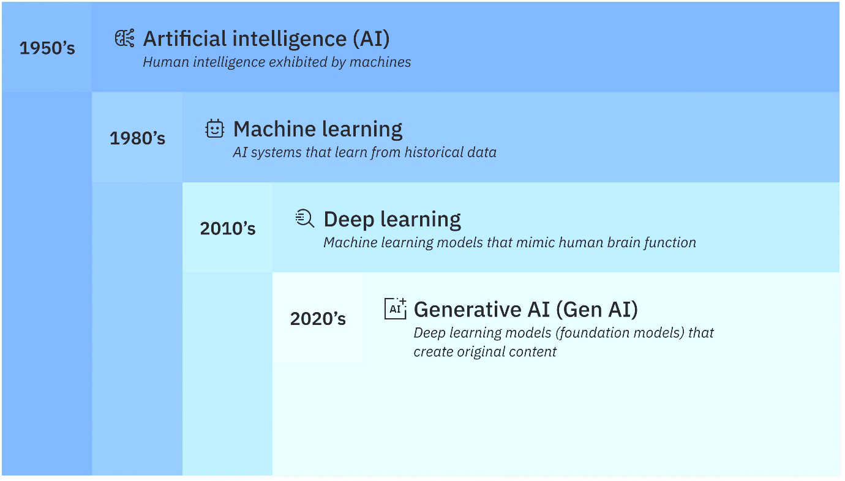

AI is as a series of nested or derivative concepts that have emerged over more than 70 years.

**Application of AI**

Artificial Intelligence (AI) has transformative applications across various sectors, enhancing efficiency, accuracy, and decision-making. Here are some prominent areas where AI is making significant impacts:

1. **Healthcare**: AI is revolutionizing patient care through predictive analytics, medical imaging, and personalized medicine. Machine learning algorithms analyze medical data to predict disease outbreaks, assist in diagnostics, and optimize treatment plans, improving patient outcomes and reducing costs.
2. **Finance**: In finance, AI algorithms are employed for fraud detection, risk management, and algorithmic trading. AI systems analyze vast amounts of transaction data in real time, identifying patterns indicative of fraud and automating trading decisions based on market trends, leading to more informed investment strategies.
3. **Retail**: AI enhances customer experience through personalized recommendations, inventory management, and chatbots. E-commerce platforms utilize AI to analyze consumer behavior, offering tailored product suggestions, while chatbots provide instant customer support, improving engagement and satisfaction.
4. **Manufacturing**: AI-driven automation and robotics streamline production processes, reduce downtime, and enhance quality control. Predictive maintenance powered by AI helps anticipate equipment failures, minimizing operational disruptions and extending machinery lifespan.
5. **Transportation**: AI underpins the development of autonomous vehicles and smart traffic management systems. Machine learning algorithms process real-time data from sensors and cameras, enabling self-driving cars to navigate safely and efficiently while reducing congestion and accidents.
6. **Education**: AI is personalizing learning experiences through adaptive learning technologies. By analyzing student performance data, AI can provide customized educational content and feedback, catering to individual learning needs.
7. **Entertainment**: In the entertainment industry, AI algorithms recommend content based on user preferences, improving user engagement on platforms like Netflix and Spotify.

Overall, AI applications are reshaping industries, driving innovation, and creating opportunities for improved efficiency and decision-making in everyday life.

**Jobs Opportunities of AI-ML**

The job opportunities in Artificial Intelligence (AI) and Machine Learning (ML) are flourishing as industries increasingly recognize the value of data-driven decision-making and automation. As businesses adopt AI technologies to enhance their operations, the demand for skilled professionals is on the rise.

***Diverse Job Roles***

* Data Scientist: Analyzes and interprets complex data to help organizations make informed decisions. They employ statistical techniques and machine learning algorithms to derive insights from data.
* Machine Learning Engineer: Designs, develops, and implements machine learning models and algorithms. They focus on optimizing model performance and integrating ML solutions into production systems.
* AI Research Scientist: Conducts research to advance the field of AI. This role involves developing new algorithms, models, and approaches to solve complex problems.
* Business Intelligence Analyst: Uses AI and data analytics tools to interpret data and provide strategic insights for business growth and decision-making.
* Data Engineer: Builds and maintains the infrastructure and architecture for data generation, processing, and storage. They ensure data is accessible for analysis.
* AI Ethics Specialist: Focuses on the ethical implications of AI technologies, ensuring compliance with regulations and promoting responsible AI use.

***Industry Demand***

AI and ML skills are in high demand across various industries, including:

* Healthcare: AI is used for diagnostics, personalized medicine, and predictive analytics.
* Finance: AI helps with fraud detection, risk management, and algorithmic trading.
* E-commerce: Companies leverage AI for recommendation systems, inventory management, and customer insights.
* Automotive: The industry utilizes AI for autonomous vehicles, predictive maintenance, and enhancing manufacturing processes.
* Telecommunications: AI is employed for network optimization, customer service automation, and predictive maintenance.

***Skill Requirements***

To succeed in AI and ML roles, candidates typically need:

* Proficiency in programming languages (e.g., Python).
* Familiarity with machine learning frameworks (e.g., TensorFlow, Keras, PyTorch).
* A solid understanding of statistics, data analysis, and data visualization.
* Knowledge of cloud platforms (e.g., AWS, Azure, Google Cloud) for deploying AI solutions.

***Future Growth***

The AI and ML job market is projected to grow significantly in the coming years. According to various industry reports, the demand for AI professionals is expected to continue rising as organizations seek to leverage AI for competitive advantage and operational efficiency. This growth presents vast opportunities for career advancement, with many companies willing to invest in training and development to build their AI capabilities.

The job opportunities in AI and ML are diverse and expanding rapidly. With the right skills and knowledge, professionals can find fulfilling and rewarding careers across a wide range of industries, contributing to the transformative impact of AI technologies on society and the economy.

# AI-ML Importance of Sustainability

The importance of Artificial Intelligence (AI) and Machine Learning (ML) in sustainability is increasingly recognized as these technologies offer powerful tools to tackle complex environmental challenges. AI and ML play crucial roles in sustainability through predictive insights, optimization capabilities, and innovative solutions that promote the responsible use of resources and address environmental impacts.

Artificial Intelligence (AI) and Machine Learning (ML) are playing a key role in tackling some of the world’s most pressing sustainability challenges. These technologies help us use resources more efficiently, reduce waste, and create innovative solutions for a healthier planet. By optimizing processes and making better predictions, AI and ML allow us to make smarter, more environmentally friendly decisions across various sectors.

**Optimizing Energy Consumption**

Energy is one of the most critical resources, and managing it effectively is essential for sustainability. AI and ML can make a big difference here by:

* **Smart Grids**: AI can predict energy demand and adjust electricity distribution, reducing waste and ensuring that power is available where it's needed most.
* **Energy Efficiency**: ML models analyze how buildings use energy and suggest ways to reduce consumption, such as optimizing heating and cooling systems to lower carbon emissions.
* **Renewable Energy**: AI helps renewable energy systems, like solar panels and wind turbines, by predicting energy production and making sure it’s stored efficiently for when it’s needed.

**Improving Agricultural Practices**

Agriculture uses a lot of the world’s resources, but AI and ML can help make it more sustainable:

* **Precision Agriculture**: Farmers can use data from drones, sensors, and satellites to monitor soil health, water usage, and crop growth, allowing them to use fewer resources while still getting great results.
* **Yield Prediction**: ML can predict how much food crops will produce, helping farmers plan better and avoid overusing water, fertilizer, and pesticides.
* **Sustainable Farming**: AI helps farmers reduce waste and improve efficiency by optimizing planting schedules and making supply chains more sustainable.

**Supporting Climate Change Mitigation**

AI and ML are also powerful tools in the fight against climate change:

* **Climate Modeling**: These technologies process vast amounts of data to improve weather and climate predictions, helping us understand how the climate is changing and what we can do to mitigate its impact.
* **Carbon Footprint Reduction**: By optimizing industrial processes, transportation routes, and energy consumption, ML can help industries reduce their carbon emissions.
* **Disaster Management**: AI can predict natural disasters like floods and wildfires, giving people more time to prepare and minimize environmental and human damage.

**Enhancing Resource Management**

AI and ML are helping us manage and conserve the Earth’s precious resources more effectively:

* **Water Management**: AI systems can monitor water quality, predict future demand, and detect leaks in water supply systems, making sure we use this vital resource wisely.
* **Waste Reduction**: ML models optimize recycling processes and promote circular economies, where products are reused or recycled instead of ending up in landfills.
* **Sustainable Supply Chains**: AI makes supply chains more sustainable by reducing energy consumption and waste during transportation and production, while ensuring materials are responsibly sourced.

**Promoting Sustainable Urban Development**

As cities grow, AI can help ensure they develop in a more sustainable way:

* **Smart Cities**: AI-powered systems can optimize traffic, reduce congestion, and improve public transportation, all of which contribute to better air quality and reduced energy consumption.
* **Sustainable Infrastructure**: ML helps design energy-efficient buildings, reducing waste and ensuring urban environments are more environmentally friendly.
* **Urban Resilience**: By predicting how climate change will affect cities, AI helps urban planners build more resilient and sustainable communities.

**Advancing Environmental Conservation**

AI and ML are essential tools for protecting the planet’s biodiversity and natural ecosystems:

* **Wildlife Monitoring**: AI systems, using drones and sensors, help track endangered species, protect wildlife from poaching, and monitor animal populations in remote areas.
* **Forest Management**: Machine learning analyzes satellite data to detect deforestation, assess forest health, and guide reforestation efforts, ensuring that forests remain healthy and productive.
* **Biodiversity Protection**: AI helps assess the impact of human activity on ecosystems, providing the insights needed to protect biodiversity and maintain balanced ecosystems.

AI and ML are transforming how industries and governments approach sustainability. By adopting these technologies, we can make more informed decisions, reduce our environmental footprint, and create a more sustainable future for generations to come. In addition to addressing environmental challenges, the application of AI and ML in sustainability opens up new opportunities for innovation, economic growth, and a cleaner, greener world.

# Types of Machine Learning

Within the field of artificial intelligence, machine learning uses statistical models and algorithms to find patterns in data and generate predictions without the need for explicit programming. Because these algorithms are developed through feedback and trial and error, machines learn by experience and greater data exposure in a manner similar to that of humans. Fraud detection, healthcare forecasting, and natural language processing are just a few of the fields and uses for machine learning.

4 Types of Machine Learning,

* Supervised learning
* Unsupervised learning
* Semi-supervised learning
* Reinforcement learning

Machine learning and its algorithms consists of four main types are supervised learning, unsupervised learning, semi-supervised learning and reinforcement learning.

**Supervised Learning**

Supervised learning involves training a machine and its algorithm using labeled training data, and requires a significant amount of human guidance. It’s one of the most popular forms of machine learning and is able to train models to accomplish tasks in classification, regression or forecasting.

In order to work, supervised learning requires a significant amount of human intervention because of its use of labeled data sets. Data must be divided into features (the input data) and labels (the output data).

Supervised learning examples are,

* Recommender systems and recommendation engines
* Inbox spam detection
* Stock and housing market value prediction

**Unsupervised Learning**

With unsupervised learning, raw data that’s neither labeled nor tagged is processed by the system, meaning less work for humans. Unsupervised learning algorithms discover patterns or anomalies in large, unstructured data sets that may otherwise go undetected by humans. This makes it applicable for accomplishing tasks related to clustering or dimensionality reduction.

Unsupervised learning algorithms work by analyzing available data and grouping information based on similarities and differences, thus creating relationships between data points.

Unsupervised learning examples are,

* Automated customer and audience segmentation
* Computer vision
* Breach and anomaly detection

**Semi-Supervised Learning**

Semi-supervised learning offers a balanced mix of both supervised and unsupervised learning. With semi-supervised learning, a hybrid approach is taken as small amounts of labeled data are processed alongside larger chunks of raw data. This strategy essentially gives algorithms a head start when it comes to identifying relevant patterns and making accurate predictions when compared with unsupervised learning algorithms, without the time, effort and cost associated with more labor-intensive supervised learning algorithms.

Because semi-supervised learning uses labeled data and unlabeled data, it often relies on modified unsupervised and unsupervised algorithms trained for both data types.

Semi-supervised learning examples are,

* Fraud detection
* Speech recognition
* Text document classification

**Reinforcement Learning**

With reinforcement learning, AI-powered computer software programs are outfitted with sensors, commonly referred to as intelligent agents, that respond to their surrounding environment to make decisions independently that achieve a desired outcome. (Think simulations, computer games and the real world.)

Intelligent agents are self-trained by being rewarded for desired behaviors or punished for undesired behaviors. By perceiving and interacting with their environment, these agents learn through trial and error, ultimately reaching optimal proficiency through positive reinforcement during the learning process.

Reinforcement learning examples are,

* Robotics
* Self-driving cars
* Helping machines acquire specific skills and behaviors

# Machine Learning Workflow

The world of AI, or Artificial Intelligence, is a rapidly advancing field that focuses on developing intelligent machines capable of performing tasks that typically require human intelligence. AI has gained significant attention and has become increasingly integrated into various aspects of our lives. As AI continues to advance, ethical considerations are vital. Addressing issues like bias in algorithms, data privacy, transparency, and the impact on the workforce is essential. Responsible AI development aims to create systems that align with human values, ensuring their beneficial and augmenting role in society.

Overall, the world of AI presents immense potential for transforming industries, improving efficiency, and enhancing our lives. Ongoing research and responsible practices will shape its future and maximize the positive impact of AI on society.

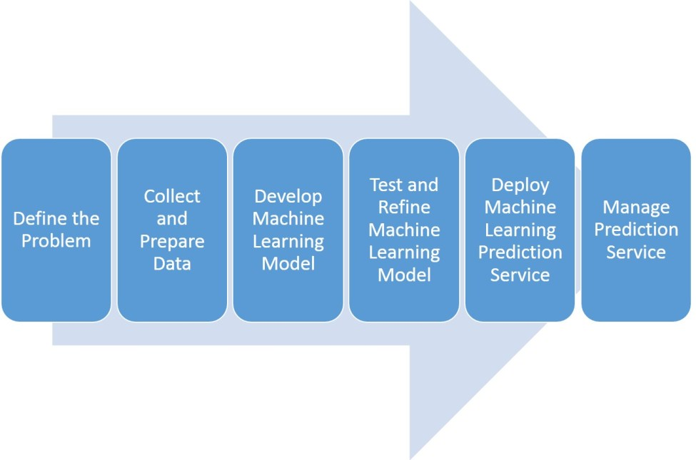

Steps of Machine Learning,

**Define the Problem**

When stakeholders come to you with a challenge or issue they wish to resolve, the machine learning pipeline starts. Gathering their requirements is the first thing you should accomplish. The procedure is much the same as what you would do in a normal IT project.

Find out from stakeholders what obstacles they are encountering and what results they anticipate. For instance:

* The business problem they need to solve
* What is causing it?
* The impact on the organization.
* What is the desired outcome?
* How would they define the success of the project?
* How do they intend to use the solution?

Once the problem is well understood, think about the following to see if machine learning is the best option:

* The issue is ongoing rather than a passing difficulty.
* It is not cost-effective to complete the task by hand.
* It can be challenging to build a computer program (coded solution). For instance, when an excessive number of branching business rules are present.
* A coded solution could be created, but scalability would be difficult.
* Each case determines the prediction result, thus you must customize it.
* Over time, the prediction function could alter.

**Collect and Prepare Data**

A machine learning solution must include data preparation and collecting. In most projects, data collection and preparation represent 80% of the effort. A significant amount of human intervention is needed at this step.

The amount of data required for any given project is not fixed.   
Three sub-steps comprise data collection and preparation: sourcing, cleansing, and preparation.

***Sourcing data involves***:

* Find the source of all the data necessary for developing the model.
* Joining multiple data sources and rationalizing them into one dataset.
* Identify features. Features is another name for the attributes of your data.
* Analyze data to look for trends.

***Common data resources:***

* data.gov: The U.S. government's open data portal provides access to thousands of datasets across various domains, including health, education, and the economy.
* Kaggle: A popular platform for data science competitions, Kaggle hosts a vast repository of datasets across various domains, ranging from finance to healthcare and sports.
* UCI Machine Learning Repository: A collection of datasets for machine learning, hosted by the University of California, Irvine, covering numerous application domains.
* Google Dataset Search: A search engine that allows users to find datasets stored across the web, making it easy to locate data on specific topics.
* OpenStreetMap: A collaborative mapping project that provides free geographic data and mapping to anyone who wants to use it, useful for urban planning and geospatial analysis
* National Institutes of Health (NIH): Offers various datasets related to health, genomics, and biomedical research.
* The Cancer Genome Atlas (TCGA): A resource that provides genomic data for various cancer types, useful for cancer research and bioinformatics.

***Cleaning Data***

Databases are prone to have missing or incorrect values. The more time the system has been in service, the worse the problem can be. It is advisable to run quality tests to find missing and inconsistent values.

If you find missing values, there are some actions you can take to clean your data, for example:

* Going back to the data source and input the missing values.
* Remove rows with missing values.
* Replace the missing value with another.
* If the missing values are numerical, replace them with the mean or median of the dataset.

***Preparing Data***

Preparing data involves transforming it into the format best suited for the Machine Learning model.

Tools like Tensorflow and Python have libraries for data preprocessing.

Some examples of data preparation are:

* Normalizing numerical data to a standard scale.
* Changing data formats.
* Simplify redundant data.
* Randomize the order of data rows to ensure that data order doesn’t affect the model.

Preparing data also involves splitting the data into two subsets. These are the training data and model evaluation data. We don’t want to use the same data used to develop the model to test it.

**Develop a Machine Learning Model**

In this step, you develop and train your Machine Learning model:

* It means choosing an established Machine Learning technique or defining a new approach.
* Python and Tensorflow have extensive libraries with many ML algorithms you can use.
* ML Cloud services, like those provided by Microsoft or Amazon, make choosing and using an ML model even more effortless.
* You can always develop a new model. However, you often will frame your ML problem into a known one (See step one).

Once you choose a model, you will begin training it. In this step, we use our data to develop our model’s ability to make predictions.

For example, training a supervised learning model would look like this:

* You already know the target values you are trying to predict. For instance, if predicting fraudulent transactions, you already know which ones are fraudulent.
* Run the model over your training data to predict those values for your training data.
* Try different model parameters until the prediction error is below a certain threshold.

**Test and Refine the Machine Learning Model**

Every learner is at risk of becoming biased. A biased Learner will make great predictions over the training dataset. However, give it a different dataset, and it will underperform.

Testing the learner with a separate dataset is necessary. Here, the “model evaluation” dataset we set aside in Step 2 comes into play.

Consider the following when testing and evaluating the learner:

* We can determine if it will perform well in the real world by feeding the model data it has not yet seen.
* We work on testing data like we did when training the model. We feed it to the model, then compare its predictions with actual values. As always, we seek an error below a predefined threshold.
* During testing, we can change operations and settings (hyperparameter tuning).

**Deploy Machine Learning Prediction Service**

Deploying the model is a task performed by Machine Learning Engineers. Their job is to turn the ML model into a software component that can receive requests from other applications.

* When developing the prediction service, consider the many channels and audiences required. Determine the needs of all software applications that will interact with the service.
* In some projects, you could recommend a limited rollout. This trial period will allow business users to work and provide feedback. After the trial, you can deploy the prediction service to a broader audience.
* Machine Learning Engineers are experts in the tools to create prediction services. Hire a team of them, and have them develop the best solution that fits your needs.
* Production and training data distribution must be similar. Otherwise, the model will make unreliable predictions.

# Machine Learning Python Package (Scikit-Learn)

Python has a rich ecosystem of machine learning packages that make it easier for developers and data scientists to build, train, and deploy machine learning models.

Here we are selected the most commonly used Python “Scikit-Learn” packages for machine learning.

Scikit-Learn is a powerful Python library widely used for machine learning and data science tasks. It’s built on top of other foundational libraries like NumPy, SciPy, and matplotlib, making it accessible and efficient for implementing a wide range of machine learning algorithms.

**Installation and Setup**

To install and set up scikit-learn, a widely used Python library for machine learning, first ensure you have Python (version 3.6 or newer) and pip, Python’s package installer.

You can check your Python and pip versions by running

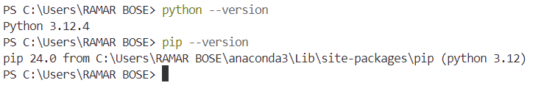

To install scikit-learn, open a terminal or command prompt / anaconda prompt or juypter notebook and type

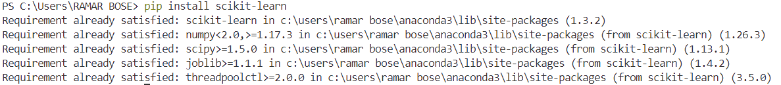

If you’re using Anaconda, you can install scikit-learn via, “conda install scikit-learn”

This command downloads and installs scikit-learn, along with its dependencies like NumPy, SciPy, and joblib. It’s often recommended to use a virtual environment for your projects to manage dependencies independently.

You can create and activate a virtual environment with,

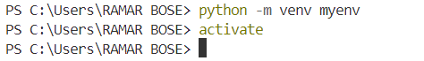

Then, install scikit-learn within this environment.

To verify the installation, open Python in your terminal,

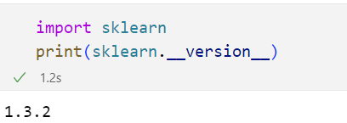

Scikit-learn is now ready for use. You can import it in your Python scripts and use its extensive suite of tools for data preprocessing, model building, evaluation, and tuning.

**Data Preparation**

Scikit-learn offers several built-in datasets that are useful for learning and experimenting with machine learning models. These datasets can be easily loaded using functions from sklearn.datasets.

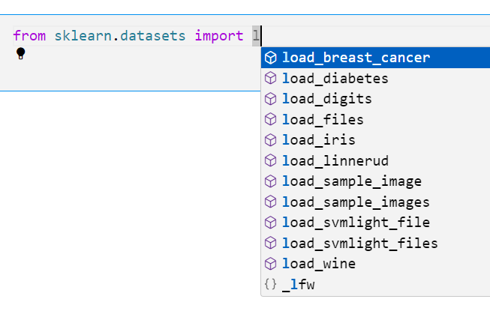

We able see all built-in datasets above.

Now, lets load built-in dataset using scikit learn,

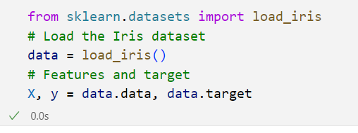

Now loaded the dataset in X, and y as features and target.

If required to Generating Synthetic Datasets,

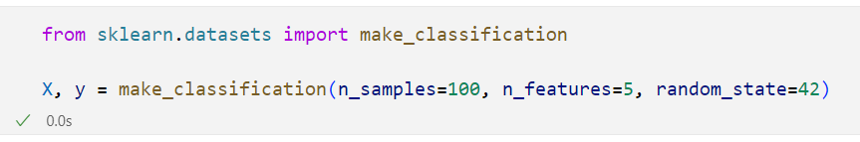

These methods make it easy to load or generate datasets for experimentation and prototyping with machine learning models in scikit-learn.

**Data Splitting**

Data splitting is an essential part of machine learning that involves dividing your dataset into separate sets for training and testing. This process helps assess a model's performance on unseen data, ensuring that it generalizes well. Scikit-learn provides convenient functions to handle data splitting efficiently.

***Train-Test Split,***

The most common way to split data is using train_test_split from scikit-learn’s model_selection module. It splits the dataset into training and testing sets, with a typical split being 80% for training and 20% for testing.

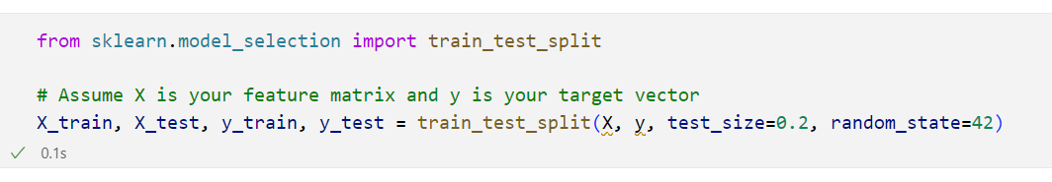

from sklearn.model_selection import train_test_split: This line imports the train_test_split function from the model_selection module of Scikit-learn. This function is used to split datasets into training and testing subsets.

X: This is the feature matrix, which contains the input variables (features) used to predict the target variable. It can be a 2D array or DataFrame where each row represents a sample and each column represents a feature.

y: This is the target vector (or label), which contains the output variable that you want to predict. It can be a 1D array or Series where each entry corresponds to the label of the respective row in X.

train_test_split(X, y, test_size=0.2, random_state=42): This function performs the split.

Parameters:

* X: The feature matrix to be split.
* y: The target vector to be split.
* test_size=0.2: This parameter specifies the proportion of the dataset to include in the test split. In this case, 20% of the data will be reserved for testing, and the remaining 80% will be used for training.
* random_state=42: This parameter is used for reproducibility. By providing a specific integer (like 42), you ensure that every time you run your code, you will get the same split of data. If you do not set a random_state, the split will be different each time you run the code, making your results hard to reproduce.

X_train, X_test, y_train, y_test: The function returns four variables:

* X_train: The training feature set (80% of the data).
* X_test: The testing feature set (20% of the data).
* y_train: The training target values (corresponding to X_train).
* y_test: The testing target values (corresponding to X_test).

***Stratified Splitting***

For classification tasks with imbalanced classes, it’s important to ensure the same class distribution in both training and testing sets. Use stratify=y to split data while preserving the class distribution.



***Cross-Validation Splitting***

Cross-validation, especially **K-Fold Cross-Validation**, splits data into K equal parts (folds). The model is trained on K-1 folds and tested on the remaining fold, and this process is repeated K times, ensuring that each fold is used as a test set once.

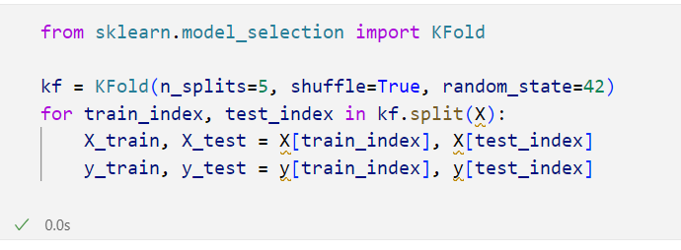

Or use **StratifiedKFold** for classification tasks to keep class balance across folds.

**Data Preprocessing**

Data preprocessing is a crucial step in the machine learning pipeline that prepares raw data for modeling. It involves cleaning, transforming, and organizing data to improve model accuracy and performance. Scikit-learn offers a variety of tools for effective data preprocessing.

***Handling Missing Values***

Missing values can negatively impact model performance. Scikit-learn provides the SimpleImputer class for filling in these gaps using strategies like mean, median, or a constant value.

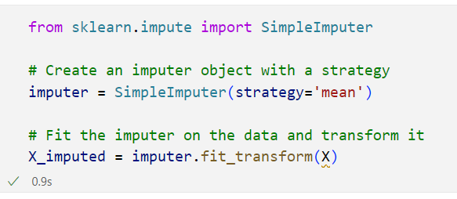

***Feature Scaling***

Feature scaling is important for algorithms sensitive to the scale of input data, such as K-Means and Support Vector Machines.

*Standardization (Z-score normalization)*

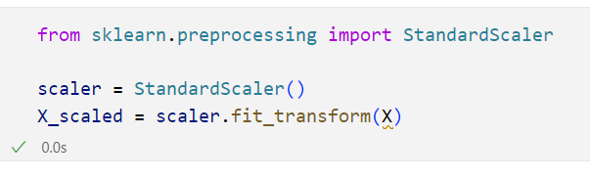

*Min-Max Scaling*

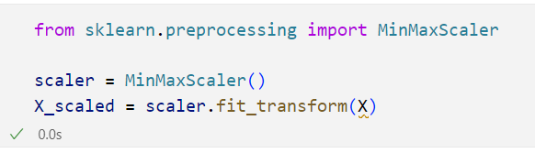

*Encoding Categorical Variables*

Machine learning models require numerical input, so categorical variables need to be encoded.

One-Hot Encoding for nominal variables,

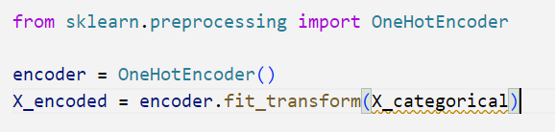

Label Encoding for ordinal variables,

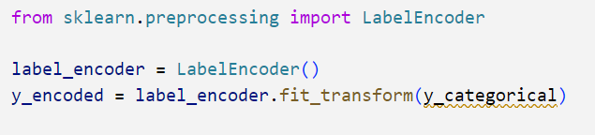

Effective data preprocessing ensures that your data is clean, well-structured, and suitable for modeling. By using the preprocessing capabilities of scikit-learn, you can enhance the accuracy and robustness of your machine learning models.

**Model Selection**

Model selection is the process of choosing the best machine learning model for a given problem based on various criteria, such as performance metrics, data characteristics, and computational efficiency. Scikit-learn provides a range of tools to facilitate this process, including model evaluation, selection, and hyperparameter tuning.

First, identify whether your problem is a classification, regression, or clustering task.

For instance:

* **Classification**: Logistic Regression, Decision Trees, Random Forest, SVM, etc.
* **Regression**: Linear Regression, Ridge Regression, Random Forest Regressor, etc.
* **Clustering**: K-Means, DBSCAN, Agglomerative Clustering, etc.

The model selection based on above, for example,

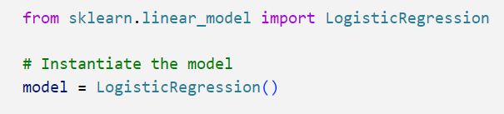

Model selection is an iterative process involving experimentation and evaluation. By systematically assessing different algorithms and their hyperparameters using scikit-learn's tools, you can identify the most effective model for your specific problem.

**Training the Model**

Training the model is a crucial step in the machine learning workflow, where the selected model learns from the training data to make predictions or classifications on unseen data. In scikit-learn, this process involves fitting the model to the training dataset and validating its performance.

Use the fit method to train the model on the training dataset. This involves passing the feature matrix (X_train) and the target vector (y_train) to the model.

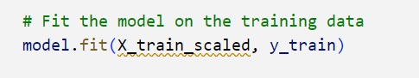

model: This variable represents an instance of a machine learning model. It could be any model from Scikit-learn, such as RandomForestClassifier, LogisticRegression, or SVC, among others. Before this line, you would have defined and instantiated your model.

.fit() Method: This method is called to train the model using the provided training data. When you fit the model, it learns the patterns and relationships in the data, allowing it to make predictions on new, unseen data.

Inputs are,

X_train_scaled: This is the feature matrix for the training data. It contains the input features (independent variables) that the model will use to learn. In this case, X_train_scaled suggests that the features have already undergone scaling (e.g., using StandardScaler or MinMaxScaler). Scaling is crucial for many models, especially those sensitive to the scale of input features, as it ensures that all features contribute equally to the model's performance.

y_train: This is the target vector (dependent variable) corresponding to the training features. It contains the true labels or values that the model aims to predict based on the features in X_train_scaled.

Process,

When you call model.fit(X_train_scaled, y_train), the following happens:

* The model processes the X_train_scaled data, analyzing the feature values.
* It applies the underlying algorithm to learn from the relationship between the features and the target values in y_train.
* The model adjusts its internal parameters (weights) based on the training data to minimize the error between its predictions and the actual target values.

the model learns from the training data. After executing this line, the model will be trained and ready to make predictions on new data using the learned patterns.

**Model Evaluation**

Model evaluation is a critical step in the machine learning workflow that assesses the performance of a trained model. It involves using various metrics and techniques to determine how well the model generalizes to unseen data. Scikit-learn provides a wide range of tools for evaluating both classification and regression models.

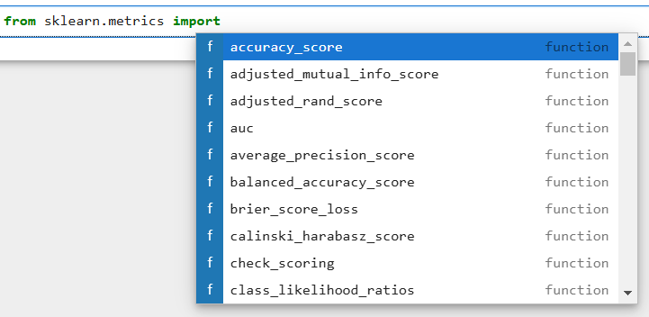

Based on the evaluation metrics, compare different models to determine which one performs best. You may also use techniques like grid search to optimize hyperparameters and improve model performance.

Model evaluation is essential for understanding how well your model performs and how it may be improved. By using scikit-learn’s metrics and tools, you can gain valuable insights into the strengths and weaknesses of your machine learning models, ultimately guiding you in refining your approach to achieve better results.

**Hyperparameter Tuning**

Hyperparameter tuning is the process of optimizing the parameters of a machine learning model to improve its performance. Unlike model parameters learned during training, hyperparameters are set before the training process begins and can significantly affect the model’s effectiveness. Scikit-learn provides several methods for hyperparameter tuning, including Grid Search and Randomized Search.

*Hyperparameter Grid for Tuning*

Define the hyperparameter grid that you want to search over. This can be a dictionary where keys are hyperparameter names and values are lists of settings to try.

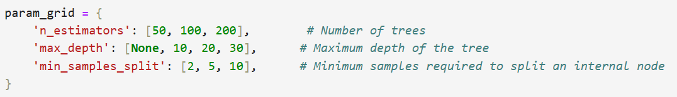

*Grid Search*

Use GridSearchCV to exhaustively search the hyperparameter space. This method evaluates all combinations of the specified hyperparameters using cross-validation.

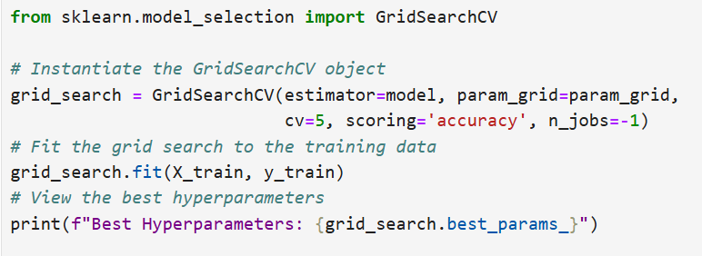

Hyperparameter tuning is a vital step in building an effective machine learning model. By systematically searching through hyperparameter configurations using Grid Search or Randomized Search in scikit-learn, you can optimize your model’s performance.

**Model Saving and Deployment**

Saving and deploying a machine learning model is an essential part of the machine learning workflow, allowing you to use your trained model in production without needing to retrain it every time. Scikit-learn makes this process straightforward through serialization, typically using Python’s pickle module or the joblib library.

You can save the model using either pickle or joblib. joblib is often preferred for large NumPy arrays, which are common in scikit-learn models.

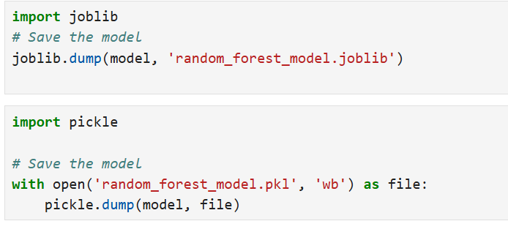

Deployment Options,

You can deploy the model in a web application using frameworks like Flask or FastAPI. This allows users to input data and receive predictions via a web interface.

Saving and deploying a scikit-learn model allows you to leverage the power of machine learning in production applications. By using joblib or pickle, you can easily serialize and deserialize your models. With deployment options ranging from web applications to cloud solutions, you can make your trained models accessible for real-world use. This process not only streamlines predictions but also enhances collaboration and reproducibility in your machine learning projects.

# Chapter 2: Supervised Learning

|  |
| --- |
| **Learning Outcomes:**   * Differentiate between classification and regression techniques and identify how each can be applied to sustainability-focused projects. * Describe real-world examples of supervised learning applications in sustainability, such as predicting energy consumption, classifying waste types, and monitoring biodiversity. * Understand the significance of error metrics (e.g., RMSE, MAE) in regression analysis and interpret their relevance for environmental forecasting. * Develop and apply regression models to predict sustainability-related outcomes, such as energy consumption, greenhouse gas emissions, or crop yields. * Evaluate the performance of supervised learning models using appropriate metrics (e.g., accuracy, precision, recall) and interpret the results in the context of environmental or sustainability goals. * Build classification models to categorize sustainability-related data, such as classifying areas of biodiversity risk, types of waste, or pollution levels. |

# 2.1 Introduction

Supervised learning (supervised machine learning) is a key technique in machine learning, used when the desired output for a particular input is known and the goal is to learn a mapping from inputs to outputs based on this labeled data. The model is trained on a dataset that includes input-output pairs, where the algorithm learns to generalize from the provided examples. After the training phase, the model can make predictions on new, unseen data.

The process involves feeding the algorithm a training dataset consisting of features (inputs) and their corresponding labels (outputs). By adjusting its internal parameters, the algorithm minimizes the difference between its predictions and the actual labels. This correction process continues iteratively, leading to a model that can accurately predict outputs for future inputs.

# 2.2 What is Supervised Learning?

Supervised learning is a type of machine learning in which a model is trained on labelled data, where the input data is paired with the correct output labels. Supervised learning algorithms learn by analysing a large dataset of labelled examples and adjusting the parameters of the model in order to minimize the error between the model’s predictions and the correct output labels. Once the model has been trained, it can be used to make predictions on new, unseen data.

One way to think about supervised learning is to compare it to a student learning from a teacher. In this analogy, the teacher is the labelled data, and the student is the machine learning model. The teacher provides the student with examples of the correct answer (the output label) along with the corresponding input data (e.g. a math problem and the correct solution). The student uses this information to learn how to solve similar problems on their own.

Once the student has learned from the teacher, they can use their knowledge to solve new problems (make predictions on new, unseen data). The teacher can also evaluate the student’s performance by testing them on problems they haven’t seen before (testing the model on a separate dataset). If the student’s performance is satisfactory, they can be considered ready to solve similar problems on their own.

Supervised learning is a type of machine learning in which a model is trained on labelled data in order to learn how to make predictions based on the patterns and relationships in the data

# 2.3 Labeled data

As the name suggests, labeled data (aka annotated data) is when you put meaningful labels, add tags, or assign classes to the raw data that you've collected. What is a label in machine learning? Let’s say you are building an image recognition system and have already collected several thousand photographs. Labels would be telling the AI that the photos contain a ‘person’, a ‘tree’, a ‘car’, and so on.

The machine learning features and labels are assigned by human experts, and the level of needed expertise may vary. In the example above, you don't need highly specialized personnel to label the photos. However, if you have, say, a set of x-rays and need to train the AI to look for tumours, it's likely you will need clinicians to work as data annotators. Naturally, due to the human resources necessary, hand-labelling data is much more expensive than gathering raw unlabelled data.

Labelled data,

* Used in supervised machine learning
* Needs human to label
* Expensive, hard and time-consuming to get and store
* Used for complex predicting tasks

Examples of labelled data,

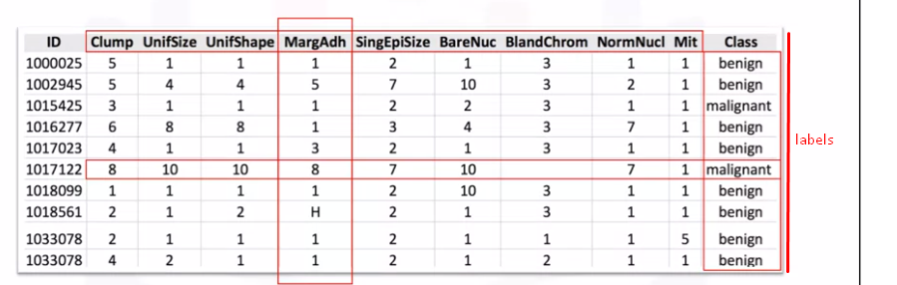

Labelled data, used by Supervised learning add meaningful tags or labels or class to the observations (or rows). These tags can come from observations or asking people or specialists about the data.

# 2.4 How Supervised Machine Learning Works?

The following picture explaining the work flow of supervised machine learning,

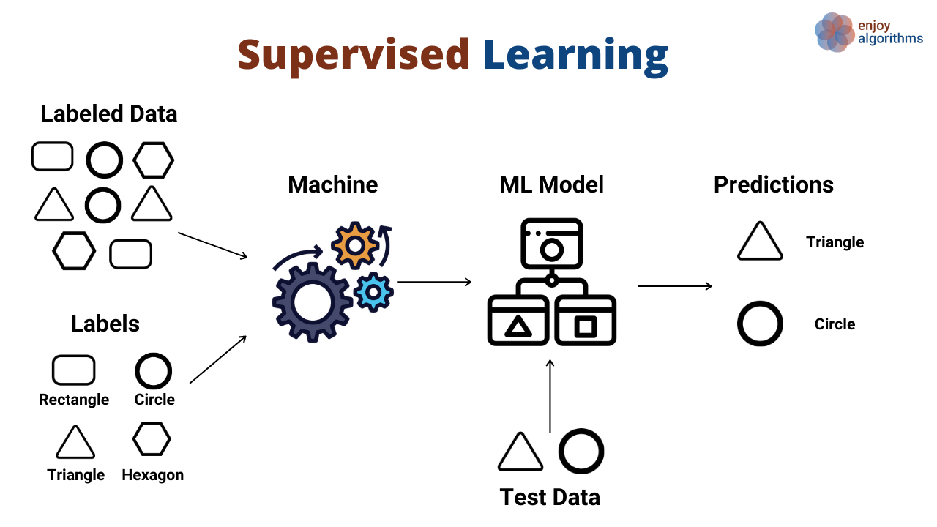

Based on the supervised machine learning work flow,

Training Phase: During the training phase, the algorithm is presented with the labelled data. It learns from this data by identifying patterns and relationships between the inputs and outputs.

Model Building: Based on the labelled data, the algorithm builds a model that can generalize from the training examples to make predictions on new, unseen data.

Prediction Phase: Once the model is trained, it can be used to make predictions on new data. The model takes an input, processes it through its learned knowledge, and produces an output prediction.

Supervised learning builds a model that maps inputs to outputs based on labeled training data. The process involves data preparation, model selection, training, evaluation, and tuning. Once complete, the model can predict outcomes for new data with high accuracy, making supervised learning essential for many applications in data science and AI.

# 2.5 Types of Supervised Learning

Supervised learning is a type of machine learning where a model is trained on labeled data, meaning the input data is paired with corresponding output labels. The goal of supervised learning is to learn a mapping from inputs to outputs so that the model can make predictions on unseen data.

There are two primary types of supervised learning,

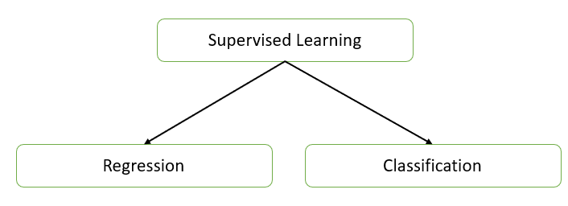

1. Regression: Regression tasks involve predicting a continuous numerical value from input data. The output variable in regression is continuous.
2. Classification: Classification tasks involve predicting a discrete label or category from input data. The output variable in classification is categorical.

Supervised learning encompasses both regression and classification, each serving different purposes based on the nature of the output variable. Understanding the types of supervised learning helps in selecting appropriate algorithms and techniques for specific problems in machine learning.

# 2.6 Supervised learning problems

Supervised learning problems are scenarios where a model is trained on labeled data, allowing it to make predictions or classifications based on input features. Here are some common supervised learning problems across various domains, categorized by classification and regression.

These regression problems involve predicting continuous numerical values from input data,

* House Price Prediction: Estimating the selling price of a house based on features such as size, location, number of bedrooms, and amenities.
* Stock Price Forecasting: Predicting the future prices of stocks based on historical price trends and other financial indicators.
* Sales Forecasting: Predicting future sales revenue based on historical sales data, marketing campaigns, and seasonal trends.
* Weather Prediction: Estimating future weather conditions (temperature, humidity, precipitation) based on historical weather data and other environmental factors.
* Energy Consumption Forecasting: Predicting energy usage in buildings or cities based on factors like time of year, weather conditions, and historical consumption patterns.
* Medical Cost Prediction: Estimating healthcare costs for patients based on their medical history, demographic data, and treatment plans.

These classification problems involve predicting discrete labels or categories from input data.

* Email Spam Detection: Classifying emails as either "spam" or "not spam" based on features like the subject line and content.
* Credit Card Fraud Detection: Identifying whether a transaction is fraudulent or legitimate based on transaction patterns and user behavior.
* Medical Diagnosis: Classifying patient data as "disease present" or "disease absent" based on medical test results and symptoms.
* Image Recognition: Classifying images into multiple categories, such as identifying objects (e.g., cars, animals, buildings) in photographs.
* Sentiment Analysis: Categorizing text (like reviews or social media posts) as "positive," "negative," or "neutral" based on the content.
* Handwritten Digit Recognition: Identifying digits (0-9) from images of handwritten numbers, commonly used in postal code reading and bank checks.

Supervised learning problems are diverse and span many domains, each requiring specific approaches and algorithms. Understanding the nature of the problem whether it involves classification or regression guides the selection of appropriate models and techniques to achieve effective predictions and insights.

# 2.7 Supervised Machine Learning Algorithms

Supervised machine learning algorithms are designed to learn from labeled data, where the model is trained on input-output pairs to make predictions on unseen data. These algorithms can be broadly classified into two categories: classification and regression.

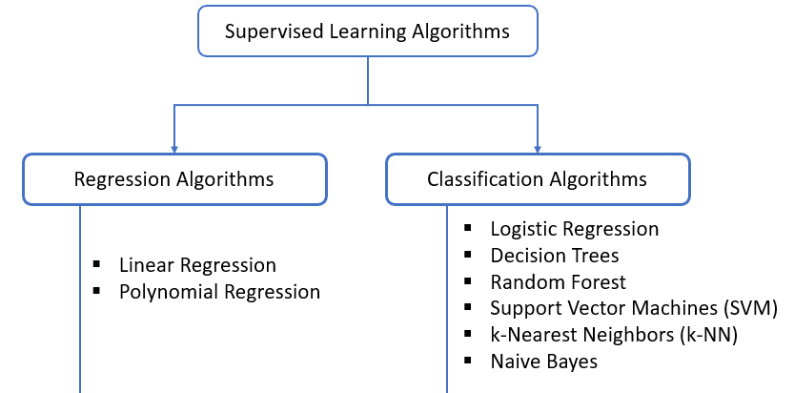

# 2.9 Regression

Regression analysis is a statistical method for modeling the relationship between a dependent variable (target) and one or more independent variables (features). It's widely used in predictive analytics, machine learning, and statistics to understand trends, make predictions, and find insights.

**Define Regression**

In simple terms, regression helps you estimate the relationship between variables. For example, you might want to predict the price of a house based on its size, number of rooms, and location. Here, the house price is the dependent variable, and the other attributes are independent variables.

**Types of Regression**

There are various types of regression techniques, each serving specific needs and assumptions:

* Simple Linear Regression: Examines the relationship between two variables (one independent and one dependent). It fits a straight line (linear function) to the data.
* Multiple Linear Regression: Extends simple linear regression by including multiple independent variables to predict the target variable.
* Polynomial Regression: Captures non-linear relationships by using polynomial terms (squared, cubed terms) of the independent variables.
* Logistic Regression: Though technically a classification algorithm, it uses regression principles for binary or multi-class classification.
* Ridge, Lasso, and Elastic Net Regression: Regularized versions of linear regression that handle multicollinearity and reduce overfitting by adding penalty terms.

**Mathematics Behind Regression**

The general formula for linear regression is



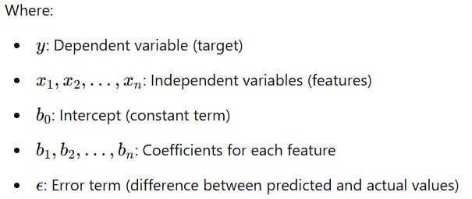

# 2.10 Regression Model Evaluation

Evaluating regression models is crucial to understanding how well they predict target values. Several metrics provide insights into model accuracy, error distribution, and generalizability.

**Type of Regression Performance Metrics**

* Mean Absolute Error (MAE)
* Mean Squared Error (MSE)
* Root Mean Squared Error (RMSE)
* R-Squared (R²)
* Adjusted R-Squared

Evaluating these metrics helps balance model complexity and predictive accuracy, guiding improvements and selecting the best model for the data.

**Mean Absolute Error (MAE)**

Mean Absolute Error (MAE) is a widely used metric for evaluating regression models, as it measures the average magnitude of errors between actual values and predicted values without considering their direction. MAE provides an intuitive sense of the average size of errors in the same units as the target variable, making it easy to interpret in real-world applications.

The formula for MAE is:

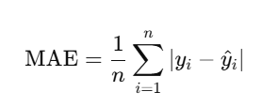

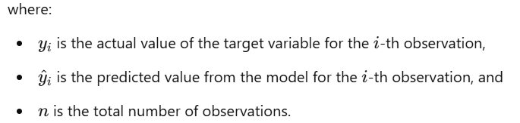

MAE calculates the average of the absolute differences (errors) between each actual and predicted value. By using absolute values, MAE avoids cancelling out positive and negative errors, making it a straightforward measure of prediction accuracy.

Example, MAE is measured in the same units as the target variable, it directly shows the average "distance" between predictions and actual values. For example, if MAE for a house price prediction model is ₹5,000, it means predictions are off by ₹5,000 on average.

**Mean Squared Error (MSE)**

Mean Squared Error (MSE) is a fundamental metric in regression analysis that measures the average squared difference between actual and predicted values. It gives a sense of how far off predictions are from the actual outcomes, providing insight into model accuracy.

Calculated as:

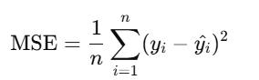

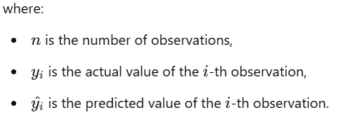

Each difference yi​−yi​^ is squared to emphasize larger errors and prevent negative and positive errors from canceling each other out. Squaring the errors also has the effect of penalizing larger errors more heavily, making MSE particularly useful when you want a model to avoid large deviations.

Interpretation of MSE, is a lower MSE indicates that predictions are close to actual values, implying a well-fitting model. However, since MSE is in squared units of the target variable, it can be challenging to interpret in the original units. For this reason, some analysts prefer the Root Mean Squared Error (RMSE), which is the square root of MSE and brings the error back to the original scale.

Note, When comparing multiple regression models, the model with the lower MSE is typically preferred. However, it’s essential to balance this with other metrics (e.g., R-Squared, MAE) and ensure that the model isn’t overfitting to the training data.

**Root Mean Squared Error (RMSE)**

Root Mean Squared Error (RMSE) is a commonly used metric in regression analysis that measures the average magnitude of error in predictions, expressed in the same units as the target variable. RMSE is calculated by taking the square root of the Mean Squared Error (MSE), which is the average of the squared differences between predicted values (y^) and actual values (y):

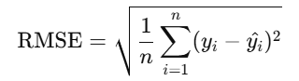

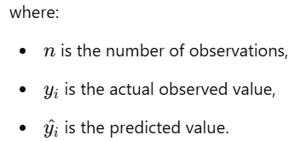

RMSE is valuable because it penalizes larger errors more than smaller ones. Since it squares the differences, large errors are amplified, making RMSE especially useful when large deviations from actual values are critical. For example, in applications where precise predictions are crucial (like weather forecasting or financial modeling), RMSE helps highlight how far off predictions can be, emphasizing the impact of outliers.

Interpreting RMSE, Since RMSE is expressed in the same units as the dependent variable, it’s directly interpretable. A lower RMSE value indicates better model performance, as it suggests the predictions are closer to actual values. However, RMSE’s interpretation depends on the context of the data and the target variable’s range; what is considered a "good" RMSE can vary greatly. For instance, an RMSE of 10 might be excellent in predicting house prices in millions but inadequate if predicting scores between 0 and 100.

Note, Compared to Mean Absolute Error (MAE), RMSE is more sensitive to outliers due to the squaring of errors. While this can be a disadvantage if data is noisy, it’s beneficial when large errors need to be minimized. Unlike R-squared, which is unitless, RMSE’s unit correspondence with the target variable adds a practical interpretation layer, especially in assessing model performance for similar models across datasets.

**R-Squared (R²)**

R-Squared (R²), also known as the coefficient of determination, is a key metric in regression analysis that measures the proportion of the variance in the dependent variable (target) that can be explained by the independent variables (features). In simpler terms, R² indicates how well the model's predictions align with the actual data points.

The formula for R² is:

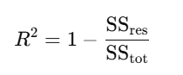

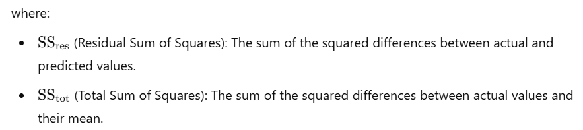

By dividing the unexplained variance (SSres​) by the total variance (SStot​), we get a fraction that indicates how much of the variation in the target variable remains unaccounted for by the model. Subtracting this fraction from 1 yields R², which represents the explained proportion of variance.

Interpretation of R² Values

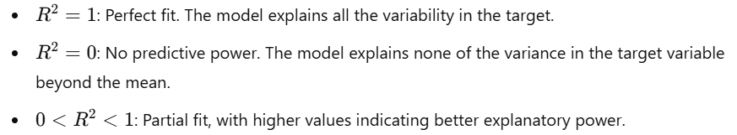

A high R² suggests the model fits the data well, but it doesn’t imply accuracy on unseen data. In fact, complex models with many features may yield high R² values on training data but perform poorly on new data due to overfitting.

**Adjusted R-Squared**

For multiple regression, Adjusted R² is often more informative. It adjusts R² for the number of predictors, preventing inflated values from adding irrelevant features.

In essence, R² is a starting point for assessing fit, but model reliability on new data should always be checked with additional metrics.

# 2.11 Understanding and Implementation of Simple Linear Regression

**Understanding of Simple Linear Regression**

Simple Linear Regression (SLR) is one of the most basic forms of regression analysis, used to model the relationship between two variables. It is a statistical technique that analyzes the relationship between one independent variable (predictor) and one dependent variable (response). The goal is to find the best-fitting straight line that describes this relationship. This line is known as the regression line.

The formula for simple linear regression is expressed as:



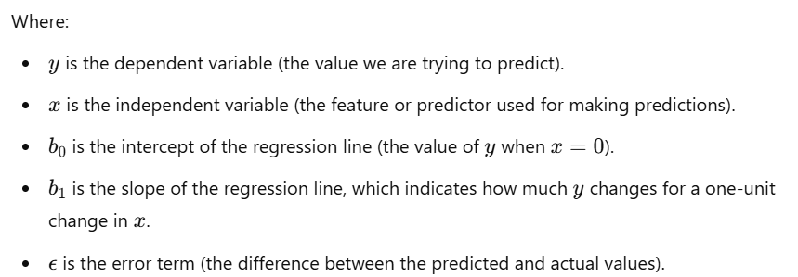

In simple terms, SLR assumes a straight-line relationship between x and y, where b1 (the slope) describes the rate of change of y with respect to x, and b0​ (the intercept) is where the line crosses the y-axis.

The main objective of SLR is to find the line that best fits the data. This is typically achieved by minimizing the sum of squared residuals (errors). The residual for each data point is the difference between the observed value of y and the predicted value. The line with the smallest sum of squared residuals provides the best model for predicting y based on x.

While simple linear regression is easy to implement and interpret, it has limitations:

* It assumes a linear relationship, which may not always be the case. For non-linear relationships, more complex models like polynomial regression might be more appropriate.
* It only works with one independent variable. If there are multiple predictors, multiple linear regression is needed.

Simple Linear Regression is a foundational tool in statistical modeling and machine learning, offering a straightforward way to model and predict relationships between two variables. By finding the best-fitting line, it provides valuable insights that can help in decision-making across a variety of fields. However, it is important to validate its assumptions and ensure the relationship between the variables is truly linear before relying on its predictions.

**Implementation Simple Linear Regression**

To implement Simple Linear Regression for predicting appliance energy consumption, you would follow a typical regression process, where you use features such as temperature, humidity, or time of day to predict energy consumption values.

*Problem Statement*

We want to predict the energy consumption of an appliance based on a given feature, such as temperature or usage time. In this case, we will use temperature as the independent variable (predictor) and energy consumption as the dependent variable (target).

*Import Necessary Libraries*

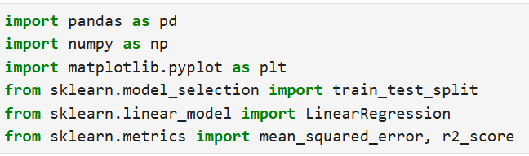

*Load Dataset*

Suppose we have a CSV file appliance_energy.csv with columns like Temperature (°C) and Energy Consumption (kWh).

Data source link (<https://github.com/ramar92/ML-Datasets-for-GreenSkill/blob/main/appliance_energy.csv> )

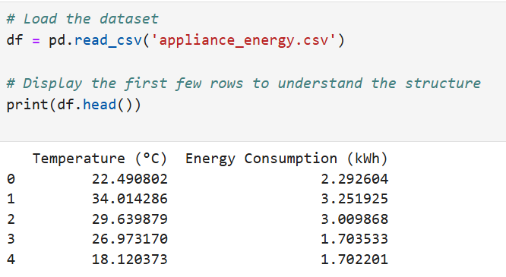

*Data Preprocessing*

Make sure there are no missing values or anomalies in the data.

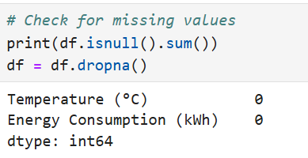

*Define Features and Target*

We define Temperature as the feature (independent variable) and Energy Consumption as the target (dependent variable).

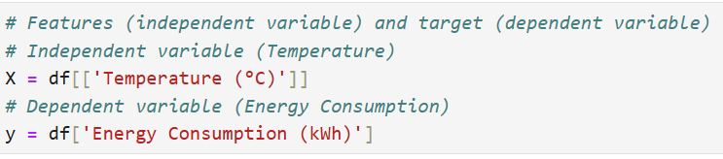

*Split the Data into Training and Testing Sets*

We’ll split the data into training and test sets, typically using 80% for training and 20% for testing.



*Create and Train the Simple Linear Regression Model*

We now create a Linear Regression model and fit it to the training data.

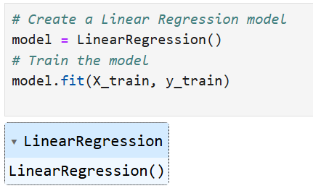

*Make Predictions*

Use the trained model to predict energy consumption based on the test set.

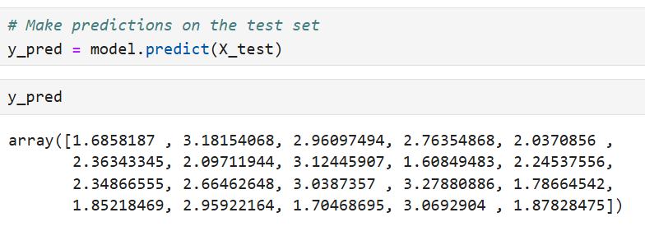

*Evaluate the Model*

Now we evaluate the model's performance using metrics like Mean Squared Error (MSE) and R-Squared (R²).

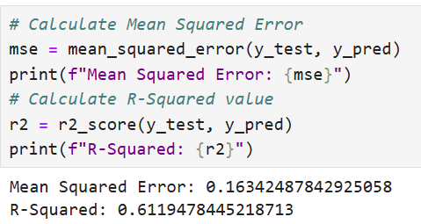

R-Squared is a measure of how well the model fits the data, where a value closer to 1 indicates a better fit.

*Visualize the Results*

Visualizing the data and the regression line can help understand how well the model is performing.

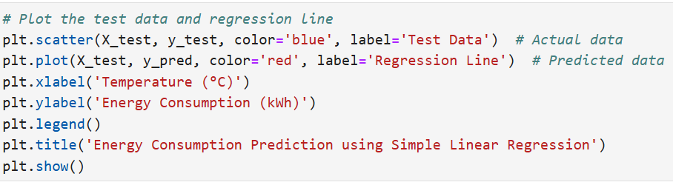

*Result*

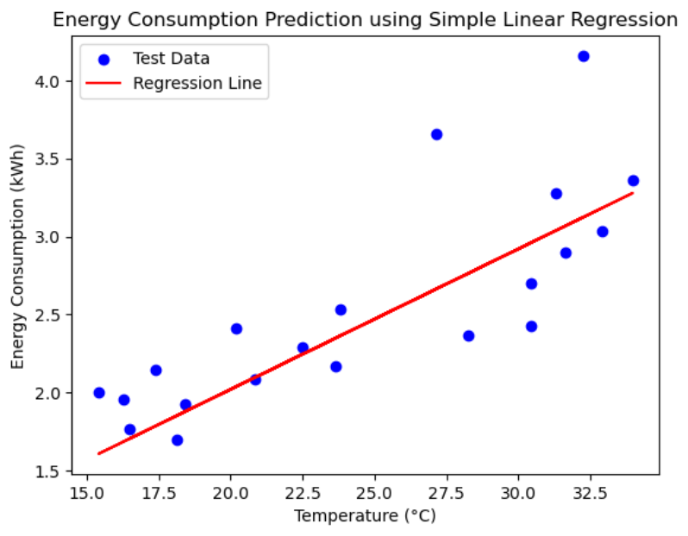

*Save the Model (Optional)*

If you want to save the trained model for future use, you can use joblib or pickle

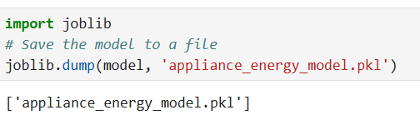

In this implementation, we used Simple Linear Regression to predict energy consumption based on temperature. By training the model and evaluating its performance using Mean Squared Error and R-Squared, we can assess how well the model fits the data. This method can be extended to include more complex features or used with larger datasets for more robust energy predictions.

# 2.13 Classification

Supervised learning classification is a subset of machine learning where the algorithm is trained on a labelled dataset, meaning the input data is paired with the correct output. This enables the model to learn from these inputs and generalize to make predictions on new, unseen data. In supervised classification, the task is to categorize input data into predefined classes or categories. This technique is commonly used in applications like email spam detection, image recognition, sustainability of green technology and medical diagnostics.

In sustainability, classification models play a valuable role in addressing environmental challenges by categorizing data to make informed predictions. Here are a few examples:

1. Energy Source Classification: A model could classify energy sources as renewable (solar, wind) or non-renewable (coal, oil). This helps energy providers optimize energy distribution and track progress toward renewable energy goals.
2. Waste Sorting: Classification models in waste management can automatically categorize waste into recyclable, compostable, or landfill. Such automation aids in efficient sorting, reducing contamination and improving recycling rates.
3. Deforestation Detection: Using satellite imagery, classification models can identify land areas as "forested," "deforested," or "at risk," allowing for targeted conservation efforts.
4. Water Quality Assessment: A model might classify water samples as "safe," "moderate," or "hazardous" based on sensor data, helping monitor water quality and enabling timely interventions.
5. Greenhouse Gas Emission Categorization: Classification models can categorize different emissions from industries, tracking them as low, moderate, or high risk, which aids regulatory agencies in enforcing policies.

In each case, the classification model uses labelled data to predict categories, contributing to sustainable decision-making, efficient resource use, and environmental conservation.

Common challenges in supervised learning classification include:

* Overfitting: Occurs when the model performs well on training data but poorly on new data.
* Class Imbalance: When one class dominates, the model may ignore the minority class, reducing accuracy for rare events.
* Data Quality: Poor-quality data can lead to unreliable models, making data preprocessing critical.

Supervised learning classification is a fundamental concept that allows machines to automatically categorize data, forming the foundation for advanced applications across numerous industries. It achieves this by learning from labelled data, enabling accurate predictions and classifications when new, unseen data is encountered.

**Types of Classification**

Classification in machine learning can be broadly categorized into different types, based on the problem setup, number of classes, and output characteristics.

* **Binary Classification**

Binary classification involves categorizing data into one of two distinct classes. It’s the simplest form of classification and is used in many applications where the decision is a "yes or no" or "true or false" scenario.

Binary classification in green skilling is valuable for identifying whether an entity or action aligns with sustainable or eco-friendly practices. Here’s an example:

**Example: Identifying Energy-Efficient Buildings**

Consider a binary classification model that determines whether buildings meet "energy-efficient" standards, classifying each building as either:

* **Energy-Efficient (Yes)**
* **Not Energy-Efficient (No)**

**Application**: This binary classification model can be applied to a dataset of building features, such as insulation quality, heating and cooling system efficiency, and energy consumption patterns. By labelling each building based on set standards, the model can identify whether a building qualifies as energy-efficient.

Binary classification in green skilling thus supports initiatives by simplifying decisions about resource allocation, training needs, and policy development focused on environmental sustainability.

* **Multi-Class Classification**

In multi-class classification, the model classifies data into one of three or more classes. Unlike binary classification, multi-class classification deals with more than two possible outcomes, and each instance belongs to only one class.

In green skilling, multi-class classification can be applied to categorize various environmental practices, energy sources, or eco-friendly certifications, where multiple classes represent different levels or types of green skills and sustainability actions.

**Example: Categorizing Skill Levels in Renewable Energy Expertise**

Suppose an organization is offering training programs focused on renewable energy skills, with trainees specializing in areas such as solar, wind, hydro, or geothermal energy. A multi-class classification model could categorize trainees based on their area of expertise to provide targeted resources.

Classes for Renewable Energy Expertise:

1. Solar Energy: Skills in solar panel installation, maintenance, and photovoltaic system design.
2. Wind Energy: Knowledge in wind turbine setup, aerodynamics, and maintenance.
3. Hydro Energy: Skills in small-scale hydro plant design and water resource management.
4. Geothermal Energy: Expertise in geothermal plant design, heat pumps, and earth-based heating systems.

Challenge in Multi-Class Classification: Each class represents a distinct area, and the model needs to assign trainees to one of these classes based on their knowledge, background, or certification achievements.

Multi-class classification in green skilling enables targeted, specialized training and development, which promotes a skilled workforce capable of supporting the transition to renewable energy and other sustainability-focused industries.

* **Multi-Label Classification**

Multi-label classification allows each instance to belong to multiple classes simultaneously. This type of classification is useful in cases where a single example may have several relevant labels or categories.

In green skilling, multi-label classification is highly relevant when assessing organizations, projects, or products that may contribute to multiple sustainability goals or practices simultaneously. Multi-label classification allows us to categorize these entities under several "green" labels, each representing a different environmental or sustainable practice.

**Example: Classifying Sustainable Building Projects**

Suppose we're assessing building projects for their alignment with various sustainability practices, such as:

* Energy Efficiency
* Water Conservation
* Waste Reduction
* Use of Recycled Materials
* Biodiversity Protection

Each building project could meet several of these criteria, so a multi-label classification model would assign multiple labels to each project as applicable. For example:

* Project A: Labeled as Energy Efficiency, Water Conservation, and Waste Reduction
* Project B: Labeled as Biodiversity Protection and Use of Recycled Materials

Benefits for Green Skilling:

1. Tailored Training Programs: With clear multi-label categorization, specific skill programs can be developed to train professionals in areas like energy auditing, sustainable water management, and eco-friendly construction practices.
2. Enhanced Reporting and Compliance: It helps organizations report on multiple sustainability criteria, ensuring they meet various regulatory and compliance standards.
3. Targeted Resource Allocation: Resources can be allocated more efficiently by focusing on specific green skills that align with the project’s sustainability labels.

Using multi-label classification, green skilling initiatives can better identify the diverse sustainability attributes of projects or products, providing a holistic approach to environmental training and resource optimization.

* **Imbalanced Classification**

Imbalanced classification is a special case where the distribution of classes is uneven, with one class significantly outnumbering others. Handling imbalanced data requires special techniques, as models might become biased toward the majority class.

**Example: Detecting Rare Eco-Friendly Practices in Agriculture**

Suppose we want to classify farms based on their adoption of sustainable agricultural practices, which may include techniques like crop rotation, organic farming, or reduced pesticide use. In many regions, however, only a small fraction of farms might use eco-friendly methods, while the majority still rely on conventional, less sustainable techniques. This creates an imbalanced classification problem where the “sustainable” farms form the minority class.

Challenge with Imbalanced Classification: Models might become biased toward the majority class (conventional farming) and ignore the minority class (sustainable practices), resulting in poor detection of farms that employ eco-friendly methods.

Solution Approaches: To handle this imbalance, techniques like oversampling (increasing instances of the minority class), undersampling (reducing instances of the majority class), or using cost-sensitive algorithms that penalize misclassification of the minority class can help.

**Ordinal Classification**

Ordinal classification deals with ordered categories. Here, the classes have a meaningful order or ranking, but the distance between them is not fixed or consistent. Ordinal classification is often used when classes represent stages, levels, or ratings.

In green skilling, an example using ordinal classification for customer satisfaction ratings might involve assessing satisfaction with eco-friendly products or sustainability initiatives.

**Example: Customer Satisfaction with Eco-Friendly Product Use**

Imagine a survey conducted to measure satisfaction with an eco-friendly product, such as biodegradable packaging. Responses are categorized into an ordinal scale:

* Poor: The product was ineffective or did not meet eco-friendly expectations.
* Average: The product was somewhat satisfactory but had some environmental or quality concerns.
* Good: The product met the customer’s needs and aligned with eco-friendly expectations.
* Excellent: The product exceeded expectations in quality and sustainability.

This feedback could help companies improve their eco-friendly offerings and align them with customer expectations, fostering both customer loyalty and environmental responsibility.

# 2.14 Classification Algorithms

Classification algorithms play a vital role in supporting green technology initiatives by helping make data-driven decisions in areas such as renewable energy, waste management, and environmental conservation. Here are some widely used classification algorithms and examples of their application in green technology,

**Logistic Regression**

Logistic regression is a simple yet powerful binary classification algorithm often used to predict probabilities of belonging to a specific class.

* **Application**: Predicting the likelihood of a building meeting energy efficiency standards.
  + **Use Case**: Logistic regression could classify buildings as either "energy-efficient" or "not energy-efficient" based on features such as insulation, heating system type, and energy consumption. This information can guide building retrofits and green certifications, encouraging sustainable construction practices.

**Decision Trees**

Decision trees split data based on feature values, creating a model that is easy to interpret and visualize. This makes them popular in environmental applications where explainability is critical.

* **Application**: Classifying waste types for efficient recycling.
  + **Use Case**: A decision tree can classify waste items as "recyclable," "compostable," or "landfill" based on features like material type, weight, and chemical composition. This supports waste management systems in automating recycling processes and reducing landfill waste.

**Random Forest**

Random forest builds multiple decision trees and combines their results, providing robustness and reducing the risk of overfitting. It’s useful for complex classification tasks in green tech.

* **Application**: Forest health monitoring using satellite images.
  + **Use Case**: A random forest model can classify sections of a forest as "healthy," "at risk," or "deforested." By analyzing factors like vegetation density, color, and texture in satellite images, it helps conservationists track forest degradation, enabling timely intervention.

**Support Vector Machines (SVM)**

Support Vector Machines create a hyperplane that best separates the classes. They are particularly effective in high-dimensional spaces, often used in environmental monitoring.

* **Application**: Identifying pollution sources in water bodies.
  + **Use Case**: SVM can classify water samples based on chemical characteristics to identify if the water source is "polluted" or "clean." This helps environmental agencies track pollution sources, mitigate contamination, and ensure safe water quality.

**K-Nearest Neighbors (KNN)**

KNN classifies data points based on the majority class of their nearest neighbors. It's useful for applications that require simplicity and real-time decision-making.

* **Application**: Species identification for biodiversity monitoring.
  + **Use Case**: KNN can classify animal or plant species based on observable features such as size, color, and habitat. This enables field scientists to monitor biodiversity and identify endangered species, aiding in ecosystem conservation efforts.

**Naive Bayes**

Naive Bayes classifiers assume independence between features and are fast and efficient, suitable for text classification and document tagging.

* **Application**: Categorizing sustainability reports or environmental news.
  + **Use Case**: Naive Bayes can classify articles or reports as "renewable energy," "climate change," "pollution control," etc. This supports green education by helping users find relevant, categorized content, promoting environmental awareness and action.

**Neural Networks**

Neural networks are highly flexible and can model complex relationships. Although more resource-intensive, they are valuable for large-scale environmental applications.

* **Application**: Solar panel defect classification in photovoltaic systems.
  + **Use Case**: Neural networks can classify solar panels as "defective" or "non-defective" based on thermal imaging data. This helps maintenance teams identify issues early, ensuring efficient energy production from renewable sources.

**XGBoost (Extreme Gradient Boosting)**

XGBoost is an ensemble learning method that uses boosting to improve model accuracy. It’s well-suited for structured data classification with high accuracy requirements.

* **Application**: Predicting species adaptability to climate change.
  + **Use Case**: XGBoost can classify species as "highly adaptable," "moderately adaptable," or "vulnerable" based on features such as habitat range, genetic diversity, and historical climate data. This information helps conservationists allocate resources effectively to protect vulnerable species.

# 2.15 Classification Model Evaluation

Evaluating the performance of a classification model is crucial to understanding its effectiveness in making predictions. Here are key metrics used in classification model evaluation, including accuracy, precision, recall, F1 score, and ROC-AUC, with definitions and examples.

**Type of Regression Performance Metrics**

* Accuracy
* Precision
* Recall
* F1 Score
* ROC-AUC (Receiver Operating Characteristic - Area Under Curve)

**Accuracy**

Accuracy measures the percentage of correctly predicted instances out of the total instances in the dataset. It’s a general metric but can be misleading when dealing with imbalanced data (where one class is significantly more common than the other).

Formula,

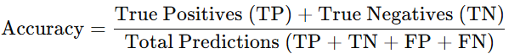

Example: In an environmental model predicting if a farm follows sustainable practices (yes or no), if the model predicts correctly 90 times out of 100, the accuracy is 90%.

**Precision**

Precision measures the proportion of true positive predictions among all positive predictions made by the model. It’s crucial when the cost of a false positive is high, as it focuses on the correctness of the positive predictions.

Formula,

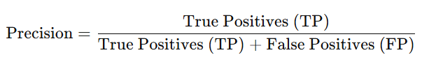

Example: For a recycling system that classifies items as "recyclable" or "non-recyclable," high precision ensures that items identified as "recyclable" truly belong in that category, reducing contamination in recycling processes.

**Recall**

Recall (or sensitivity) measures the proportion of actual positive instances that the model correctly identified. It’s essential when the cost of a false negative is high, meaning missing a true positive has significant consequences.

Formula,

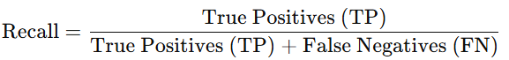

Example: In a model that detects forest fires, high recall ensures that most real fires are identified, even if it means some non-fires are also flagged. This minimizes the chance of missing real fire cases, which could lead to severe environmental harm.

**F1 Score**

The F1 score is the harmonic mean of precision and recall, providing a balanced metric that accounts for both false positives and false negatives. It is especially useful for imbalanced datasets, where accuracy alone might not be representative of the model’s performance.

Formula,

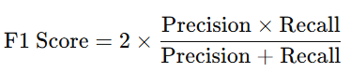

Example: For a model predicting endangered species, the F1 score balances recall (ensuring endangered species aren’t missed) and precision (avoiding unnecessary conservation efforts for non-endangered species).

**ROC-AUC (Receiver Operating Characteristic - Area Under Curve)**

The ROC-AUC score evaluates the model’s ability to distinguish between classes across various threshold settings. The ROC curve plots the true positive rate (sensitivity) against the false positive rate, and the AUC (Area Under Curve) summarizes the overall performance. A higher AUC indicates better discriminatory ability.

* True Positive Rate (Recall): Measures how well the model identifies true positives.
* False Positive Rate: Measures how often the model incorrectly predicts a positive.

Example: For a green building classification model (efficient vs. inefficient), an AUC close to 1.0 indicates the model can reliably distinguish between energy-efficient and non-efficient buildings. AUC is particularly helpful when balancing precision and recall, or when deciding on an optimal threshold for classification.

Finally,

* Accuracy: Best when classes are balanced and misclassification costs are low.
* Precision: Useful when false positives are costly, as in contamination detection in recycling.
* Recall: Important when false negatives are costly, like in forest fire detection models.
* F1 Score: Effective for imbalanced datasets, balancing the needs of precision and recall.
* ROC-AUC: Ideal for evaluating binary classifiers' overall performance and comparing multiple

Using these metrics, practitioners can assess the effectiveness of a classification model in environmental and sustainability applications, making informed decisions to improve and optimize outcomes.

# Chapter 3: Unsupervised Learning

|  |
| --- |
| **Learning Outcomes:**   * Explain the role of unsupervised learning in sustainability by highlighting its potential in analyzing large, unlabelled environmental datasets. * Use clustering techniques to identify patterns in sustainability data, such as categorizing regions based on energy consumption, air quality, or waste production. * Apply dimensionality reduction methods, such as PCA and t-SNE, to simplify complex sustainability datasets for easier visualization and analysis. * Apply evaluation metrics and visualization techniques to interpret the results of unsupervised models in the context of sustainability goals. |

# 3.1 Introduction to Unsupervised Learning

Unsupervised learning is a type of machine learning where the model is trained on unlabeled data, with the objective of uncovering hidden patterns, groupings, or structures within the data. Unlike supervised learning, unsupervised learning does not rely on labeled outputs and is often used for exploratory data analysis, anomaly detection, and data compression.

Unsupervised learning, a key area of machine learning, plays a vital role in the sustainability of green technology. Unlike supervised learning, which relies on labeled data, unsupervised learning works with unlabeled data, identifying patterns, structures, and relationships within it. This characteristic makes it particularly useful for environmental and sustainability applications, where diverse and unstructured data is abundant, such as climate records, biodiversity data, or renewable energy readings.

# 3.2 What is Unsupervised Learning

Unsupervised learning is a type of machine learning where algorithms analyze and model data without any predefined labels or outputs. Unlike supervised learning, which uses labeled data to train models, unsupervised learning deals with unlabeled data, exploring patterns, structures, and relationships within the data on its own.

Unsupervised learning techniques include clustering, dimensionality reduction, and anomaly detection. Each method offers unique ways of processing data to support sustainable initiatives:

* **Clustering** groups similar data points together, uncovering natural patterns in large datasets. For instance, clustering can segment land use types in satellite imagery, aiding in monitoring deforestation or urban expansion.
* **Dimensionality Reduction** simplifies complex datasets while retaining important information. This is especially helpful in energy systems where multivariate data (like solar intensity, temperature, and humidity) needs processing.
* **Anomaly Detection** identifies rare events or outliers, which can be crucial for detecting environmental abnormalities, such as unexpected pollution levels or ecosystem disturbances.

The potential of unsupervised learning in sustainability is vast, as it can continuously learn from large, complex, and unstructured environmental datasets. However, challenges remain, including data quality and interpretability. Green technology applications require robust data preprocessing to handle inconsistencies in ecological and sensor data. Additionally, interpreting unsupervised learning results can be complex, as the lack of labelled data complicates understanding the meaning of identified patterns.

# 3.3 Unlabeled data

Unlabelled data is crucial in advancing the sustainability of green technology, as it provides vast, untapped resources for identifying environmental patterns, improving resource management, and driving innovative eco-friendly solutions. Unlabeled data refers to raw data that lacks predefined categories or outcomes. This type of data—often collected from sensors, satellites, and other IoT devices—is abundant in environmental applications, offering a rich source of insights once processed through unsupervised learning and other AI techniques.

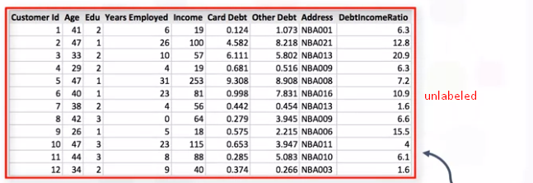

In the context of sustainability, unlabeled data holds significant potential. While labeled data is typically costly and labor-intensive to obtain, unlabeled data can be collected at scale and continuously in real-time. This data comes from numerous sources like satellite imagery, climate sensors, smart meters, and drones, offering up-to-date insights into environmental factors. By leveraging this raw data, machine learning models can identify patterns related to renewable energy, pollution levels, wildlife habitats, and more.

Despite its potential, using unlabeled data presents challenges, especially in sustainability applications. The complexity and volume of environmental data require advanced preprocessing to ensure meaningful results. Additionally, interpreting the patterns detected by unsupervised learning models can be difficult without domain expertise. Addressing these challenges demands interdisciplinary collaboration between data scientists and environmental experts.

Unlabeled data serves as a foundation for green technology advancements. By extracting insights from vast, raw datasets, we can make more informed, sustainable decisions and enhance the efficiency of environmental initiatives. As data collection methods improve and machine learning algorithms evolve, the role of unlabeled data in sustainability will continue to grow, paving the way toward a more eco-friendly future.

# 3.4 How Unsupervised learning works?

Unsupervised learning is a type of machine learning method that finds underlying patterns in data without needing any answers upfront.

Unlike supervised learning, where you give the model all the right answers, unsupervised learning explores data on its own. The model can then identify natural groupings or relationships to uncover fresh insights.

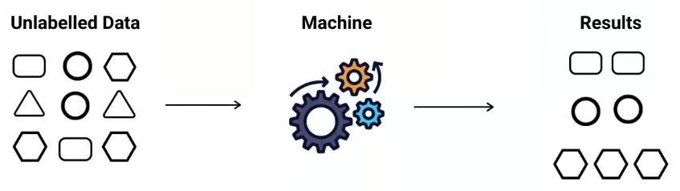

Unsupervised learning works by analyzing data to identify patterns, relationships, and structures within it—without any prior labeling or defined outputs. Unlike supervised learning, which relies on labeled datasets (data paired with correct answers), unsupervised learning deals with raw, unlabeled data, meaning the model has to explore the data on its own to find meaningful insights. The main goal is to understand the underlying structure of the data, categorize it, or reduce its complexity.

**Steps**

**Data Collection and Preparation**:

* **Data Collection**: The process begins with gathering a large set of unlabeled data. This could include images, sensor readings, text, or other data types that have no associated labels or classifications.
* **Data Preprocessing**: Raw data often requires cleaning and preparation to be useful. Preprocessing can include scaling, normalizing, or transforming the data into a suitable format. For instance, if the data includes numerical values, they may need to be scaled to fall within a specific range for better model performance.

**Selecting an Unsupervised Learning Algorithm**:

* Depending on the objective, different algorithms can be used. The two main types of unsupervised learning tasks are clustering and dimensionality reduction.
* Clustering algorithms, like K-Means or Hierarchical Clustering, group similar data points together based on defined similarity measures. This is helpful in applications like customer segmentation.
* Dimensionality Reduction techniques, such as Principal Component Analysis (PCA) or t-SNE (t-Distributed Stochastic Neighbor Embedding), simplify data with many variables, which helps in visualizing high-dimensional data and reducing computation time.

**Pattern Identification**:

* The model processes the unlabeled data to find hidden patterns, structures, or groupings. For clustering, this could mean identifying natural groupings among data points based on their attributes. In dimensionality reduction, the model tries to find the most important features in the data, reducing the total number of variables without losing key information.
* For instance, in clustering, data points are assigned to clusters based on the distance between them. In K-Means, each data point is assigned to the nearest centroid, which represents the center of a cluster, and the centroids adjust iteratively until they reach an optimal position.

**Evaluation and Interpretation**:

* Since there are no predefined labels, evaluating the quality of an unsupervised model can be challenging. Evaluation techniques like Silhouette Score for clustering (measuring how well-separated the clusters are) or Variance Explained for dimensionality reduction (indicating how much information the reduced data retains) are commonly used.
* Interpretation of results is another challenge since patterns are found without any human-defined categories. Experts in the domain are often required to analyze the clusters or components and assign meaning to them.

# 3.5 Types of Unsupervised Learning and Algorithms

By identifying patterns and structures within raw data, unsupervised learning enables a variety of applications—from environmental monitoring to efficient resource management. In sustainability, two primary types of unsupervised learning, clustering and dimensionality reduction, provide valuable insights by grouping similar data points and simplifying complex datasets, respectively.

1. **Clustering**

Clustering is a fundamental technique in unsupervised learning where the algorithm groups data points into clusters based on their similarity. Each cluster ideally represents a group of items with common characteristics, making it particularly useful in areas of green technology where there is a need to categorize vast data efficiently.

Popular clustering algorithms in sustainability include:

* **K-Means**: Groups data into a predefined number of clusters by minimizing the distance between data points and the centroid of each cluster.
* **Hierarchical Clustering**: Builds a tree of clusters, useful for data with natural group hierarchies like ecosystems or soil types.

**Dimensionality Reduction**

Dimensionality reduction simplifies high-dimensional datasets by reducing the number of variables while preserving important information. This technique is essential for green technology applications, where datasets can be large and complex—like satellite images, climate datasets, or energy grids.

* **Principal Component Analysis (PCA)** reduce this complexity, allowing researchers to focus on key factors influencing climate change without losing crucial information.
* Sustainable farming generates vast datasets, from soil health metrics to crop yields. Dimensionality reduction, particularly through **t-SNE (t-Distributed Stochastic Neighbor Embedding)**, helps farmers and agronomists visualize complex relationships, like the impact of soil properties on crop performance.

# 3.6 Unsupervised Learning Algorithms

Evaluation techniques such as Silhouette Score, Adjusted Rand Index (ARI), and Normalized Mutual Information (NMI) are essential in assessing the performance of unsupervised learning models, especially for applications in sustainability and green technology. When implementing unsupervised learning algorithms like clustering for sustainable initiatives, these metrics help determine the quality of identified clusters, allowing researchers and policymakers to make data-driven decisions based on meaningful groupings within complex, unlabeled datasets.

# 3.7 Evaluation Techniques

Evaluation techniques such as Silhouette Score, Adjusted Rand Index (ARI), and Normalized Mutual Information (NMI) are essential in assessing the performance of unsupervised learning models, especially for applications in sustainability and green technology. When implementing unsupervised learning algorithms like clustering for sustainable initiatives, these metrics help determine the quality of identified clusters, allowing researchers and policymakers to make data-driven decisions based on meaningful groupings within complex, unlabeled datasets.

**Silhouette Score**

The Silhouette Score measures the separation distance between clusters, indicating how well each data point lies within its cluster compared to other clusters. This metric is particularly helpful in evaluating clustering for tasks like monitoring pollution hotspots or identifying renewable energy usage patterns.

The formula for the Silhouette Score S(i) of a single data point i is,

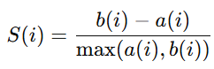

where:

* a(i) is the average distance between point iii and all other points in the same cluster (intra-cluster distance).
* b(i) is the minimum average distance from point iii to all points in the nearest neighboring cluster (inter-cluster distance).

The Silhouette Score ranges from -1 to 1:

* **1**: indicates that the data points are well-clustered and far from neighboring clusters.
* **0**: suggests that clusters are overlapping or indistinguishable.
* **-1**: indicates that the clustering is poor, as data points may be assigned to the wrong cluster

In sustainability, a high Silhouette Score indicates well-defined clusters for applications like grouping regions by air quality or renewable energy patterns, ensuring effective monitoring and intervention.

**Adjusted Rand Index (ARI)**

The Adjusted Rand Index (ARI) is a statistical measure that evaluates the similarity between two clustering assignments while adjusting for the chance grouping of elements. ARI is particularly useful for sustainability efforts where the ground truth labels (like manually identified conservation zones) may be compared with machine-generated clusters.

The ARI formula is,

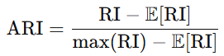

where:

* **RI (Rand Index)** counts the agreement between pairs of elements, considering pairs that are either in the same cluster in both clusterings or in different clusters in both.
* E[RI] represents the expected RI under a random model.

The ARI ranges from -1 to 1:

* **1**: indicates perfect clustering agreement with ground truth.
* **0**: reflects random labeling.
* **Negative values** indicate worse-than-random labeling.

In green technology applications, ARI can assess how well the clusters (e.g., regions with high biodiversity) align with established ecological boundaries, aiding in conservation planning and resource allocation.

**Normalized Mutual Information (NMI)**

The Normalized Mutual Information (NMI) measures the mutual dependence between two clustering results, essentially quantifying how much information is shared between the true labels and the predicted clusters. NMI is valuable in sustainability applications where we want to evaluate clusters (e.g., areas of water scarcity or air pollution) against known categories or risk levels.

The NMI formula is,

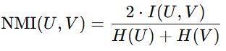

where:

* U and V are two clustering assignments.
* I(U,V) is the mutual information between U and V, measuring the amount of shared information.
* H(U) and H(V) are the entropies of U and V, representing the uncertainty in each clustering assignment.

NMI ranges from 0 to 1:

* **1**: indicates a perfect match between the two clusterings.
* **0**: suggests that the clusterings are independent.

In sustainability, NMI can be used to compare clusters of air quality zones or renewable energy adoption regions against labeled environmental risk levels, providing insights into environmental trends and intervention areas.

In green technology, evaluating clustering performance with metrics like Silhouette Score, ARI, and NMI is crucial for deriving actionable insights. These techniques allow us to validate the quality of clusters generated from unlabeled environmental data, such as identifying pollution sources, categorizing biodiversity hotspots, and understanding energy consumption patterns. By using these metrics, data scientists can ensure that the clustering models offer meaningful information that supports sustainable and eco-friendly initiatives, helping policymakers make informed, impactful decisions for a greener future.

# References

1. Bishop, C. M. (2006). *Pattern Recognition and Machine Learning.* Springer.
2. Aggarwal, C. C., & Zhai, C. (2012). *Mining Text Data.* Springer.
3. Goodfellow, I., Bengio, Y., & Courville, A. (2016). *Deep Learning.* MIT Press.
4. Hartigan, J. A., & Wong, M. A. (1979). "Algorithm AS 136: A k-means clustering algorithm." *Journal of the Royal Statistical Society, Series C (Applied Statistics).*
5. Hastie, T., Tibshirani, R., & Friedman, J. (2009). *The Elements of Statistical Learning.* Springer.
6. Jain, A. K., Murty, M. N., & Flynn, P. J. (1999). "Data clustering: A review." *ACM Computing Surveys, 31(3),* 264–323.
7. Friedman, J., Hastie, T., & Tibshirani, R. (2001). *The Elements of Statistical Learning.* Springer Series in Statistics.
8. MacQueen, J. B. (1967). "Some methods for classification and analysis of multivariate observations." *Proceedings of the Fifth Berkeley Symposium on Mathematical Statistics and Probability, 1,* 281–297.
9. Kohonen, T. (1982). "Self-organized formation of topologically correct feature maps." *Biological Cybernetics, 43(1),* 59–69.
10. Peltoniemi, M. (2022). "Applications of machine learning in sustainable environmental management." *Journal of Environmental Management, 331*, 112723.
11. Bonaccorso, G. (2017). *Machine Learning Algorithms.* Packt Publishing.
12. Shlens, J. (2014). "A tutorial on principal component analysis." *arXiv preprint arXiv:1404.1100.*
13. Tenenbaum, J. B., de Silva, V., & Langford, J. C. (2000). "A global geometric framework for nonlinear dimensionality reduction." *Science, 290(5500),* 2319–2323.
14. van der Maaten, L., & Hinton, G. (2008). "Visualizing data using t-SNE." *Journal of Machine Learning Research, 9,* 2579–2605.
15. UCI Machine Learning Repository. (2023). *Sustainability and Machine Learning Dataset Collection.*
16. Singh, R., & Singh, K. (2023). "Clustering applications in agriculture and environmental sciences." *Agricultural Informatics Journal, 12(4),* 129–142.
17. Fiorucci, L., & Schenker, M. (2019). "Detecting climate anomalies through unsupervised learning." *Climatic Change Studies,* 18(1), 67–82.
18. Li, C., Zhang, X., & Yu, J. (2020). "Renewable energy site selection using machine learning." *Renewable Energy Journal, 45(3),* 431–446.
19. Liu, S., & Li, H. (2021). "Application of ML in sustainable waste management." *Journal of Sustainable Development, 28(6),* 513–529.
20. Breiman, L. (2001). "Random forests." *Machine Learning, 45(1),* 5–32.
21. Dong, X., & He, D. (2020). "Using unsupervised learning for water quality monitoring." *Environmental Monitoring and Assessment, 192(3),* 139.
22. Ahn, C. H., & Lee, M. J. (2018). "Energy consumption prediction using unsupervised learning techniques." *Energy Informatics Journal, 24(4),* 401–411.
23. Jia, H., & Zheng, C. (2021). "Machine learning for air quality improvement." *Environmental Health Perspectives, 48(2),* 201–214.
24. UN Environment Programme. (2022). *Data-Driven Climate Solutions.*
25. Larsen, G., & Harlan, K. (2019). "Urban heat islands and ML applications for green space planning." *Sustainable Cities Journal, 20(5),* 255–267.
26. European Environment Agency. (2023). *AI and Machine Learning for Sustainable Development.*
27. Pedregosa, F., et al. (2011). "Scikit-learn: Machine Learning in Python." *Journal of Machine Learning Research, 12,* 2825–2830.
28. Jordan, M. I., & Mitchell, T. M. (2015). "Machine learning: Trends, perspectives, and prospects." *Science, 349(6245),* 255–260.
29. Thomas, S., & Smith, J. (2021). "Unsupervised learning for biodiversity conservation." *Conservation Biology, 32(4),* 873–889.
30. Panigrahi, S., & Das, A. (2022). "Crop health monitoring with ML techniques." *Journal of Sustainable Agriculture, 16(3),* 307–317.

**Disclaimer: The content is curated from online/offline resources and used for educational purpose only**